**RMU: THE MV SWITCHGEAR**

**A PROJECT REPORT**

***Submitted by***

**SRIVAIBHAVI.B (211419105143)**

***in partial fulfillment for the award of the degree***

***of***

**BACHELOR OF ENGINEERING**

**IN**

ELECTRICAL AND ELECTRONICS ENGINEERING



**PANIMALAR ENGINEERING COLLEGE**

**(An Autonomous Institution, Affiliated to Anna University, Chennai)**

**APRIL 2023**

**PANIMALAR ENGINEERING COLLEGE**

**(An Autonomous Institution, Affiliated to Anna University, Chennai)**

**BONAFIDE CERTIFICATE**

Certified that this project report **“RMU: THE MV SWITCHGEAR”** is the bonafide work of **“SRIVAIBHAVI.B (211419105143)”** who carried out the project under my supervision.

Signature of the HOD Signature of the Supervisor

Dr. S. Selvi Mrs. R.J. Suganya

PROFESSOR SUPERVISOR

HEAD OF THE DEPARTMENT, ASSISTANT PROFESSOR,

Department of Electrical and Department of Electrical and

Electronics Engineering, Electronic Engineering,

Panimalar Engineering College, Panimalar Engineering College,

Chennai – 123 Chennai – 123

Submitted for End Semester Project Viva Voce held on …………….at Panimalar Engineering College, Chennai.

**INTERNAL EXAMINER EXTERNAL EXAMINER**

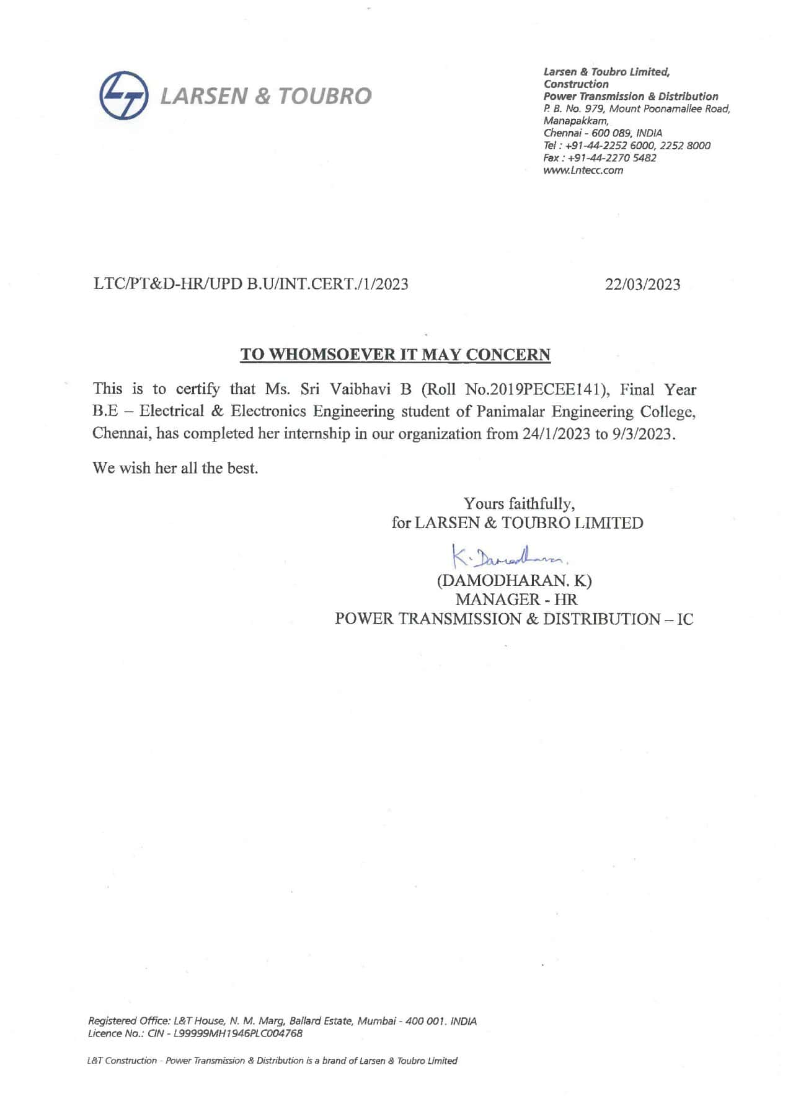

**ACKNOWLEDGEMENT**

Our sincere thanks to our Honourable Founder and Chairman, **Dr.JEPPIAAR,M.A.,B.L.,Ph.D.,** for his sincere endeavour in educating us in his premier institution.

We would like to express our deep gratitude to our beloved **Secretary and Correspondent, Dr.P.CHINNADURAI, M.A.,M.Phil.,Ph.D** for his enthusiastic motivation which inspired us a lot in completing this project and our sincere thanks to our Directors **Mrs.C.VIJAYA RAJESWARI, Dr.C.SAKTHI KUMAR, M.E.,Ph.D**  and **Dr.SARANYASREE SAKTHIKUMAR,B.E,M.B.A,Ph.D** for providing us with the necessary facilities for the completion of this project.

We would like to express thanks to our Principal, **Dr. K. Mani M.E., Ph.D.,** for having extended his guidance and cooperation.

We would also like to thank our **Head of the Department**, **Dr.S. Selvi, M.E., Ph.D., Professor and Head, Department of Electrical and Electronics Enginering** for her encouragement.

Personally, we thank our Guide **Mrs. M.J.Suganya,M.E., Professor, Department of Electrical and Electronics engineering** for the persistent motivation and support for this project, who at all times was the mentor of germination of the project from a small idea.

We express our sincere thanks to the project coordinators **Dr.S.Deepa** **&** **Dr.N.MANOJ KUMAR,M.E.,Ph.D., in Department of Electrical and Electronics Engineering** for the Valuable suggestions from time to time at every stage of our project.

Finally, we would like to take this opportunity to thank our family members, faculty and non-teaching staff members of our department, friends, well-wishers who have helped us for the successful completion of our project.

**ABSTRACT**

The main objective of the project is to install RMU (Ring Main Unit) in the electrical power distribution network is to provide a safe, reliable and efficient way to switch, protect and control the distribution system i.e., easy make and break of the network, fault finding in the network, Control and protection of the load network. The Ring main units are used to isolate the faulty portion of the feeder network, taking care of protection of the equipment and to maintain the continuity of power supply to customers. The RMU provides a high degree of safety and reliability, and it is easy to install, maintain and operate. Ring main units also reduce the need for manual intervention by linemen, as they can be programmed to automatically switch to a backup power supply in the event of a power outage. The ring main unit is small in size and can adapt to all kinds of buildings. It can be used for long-term stable power supply and infrequent high voltage switching operation. Ring main unit, because of its inherited properties is now widely used in residential buildings, public places, factory buildings and other buildings, especially in medium and small capacity compact stations. It can also be controlled from substation itself by employing Supervising control and data acquisition (SCADA) System by inbuilt Feeder remote terminal unit (FRTU) provision which used to analyze the system functioning with the help of multifunction transducers by Modbus communication channel and transfers the real time data to control center. The controller makes decision based on the data obtained from the FRTU.

**TABLE OF CONTENTS**

|  |  |  |
| --- | --- | --- |
| **CHAPTER NO.** | **TITLE** | **PAGE NO.** |
|  | LIST OF FIGURES | I |
|  | LIST OF TABLES | IV |
|  | LIST OF ABBREVIATIONS | V |
|  |  |  |
| **1.** | **INTRODUCTION** | 1 |
|  | 1. OVERVIEW 2. OBJECTIVE OF EMPLOYING RMU IN DISTRIBUTION NETWORK 3. RING MAIN UNIT FUNCTIONS 4. SINGLE LINE DIAGRAM OF RING MAIN UNIT 5. SYMBOLS OF COMPONENTS 6. GENERAL SPECIFICATION 7. TYPES OF RMU | 1  5  6  7  8  9  10 |
| **2.** | **COMPONENTS OF RING MAIN UNIT** | **12** |
|  | 1. LOAD BREAK SWITCH 2. CIRCUIT BREAKER 3. Vacuum Circuit Breaker 4. CURRENT TRANSFORMER 5. POTENTIAL TRANSFORMER 6. OVERCURRENT AND EARTH FAULT RELAY 7. Earth Fault Protection 8. Over Current Protection 9. Types Of Over Current Relay 10. 24V BATTERY CHARGER WITH BATTERY 11. AUXILIARY TRANSFORMER 12. VOLTAGE PRESENCE INDICATING SYSTEM 13. FAULT PASSAGE INDICATOR | 13  14  15  16  19  19  20  20  21  25  26  26  27 |
| **3.** | **PRE-COMMISSIONING TESTING OF RING MAIN UNIT** | **28** |
|  | 1. REQUIREMENTS OF TESTING KITS AND INSTRUMENTS 2. TYPES OF TESTS 3. Insulation Resistance Measurement Test 4. Trip Coil/Close Coil Resistance Measurement Of CB 5. Opening/Closing Time Measurement Test Of CB 6. Main circuit contact resistance measurement test of CB 7. Pre-Commissioning Test For CB 8. Pre-Commissioning Test For Switchgear PT 9. Insulation Resistance Test For Bus Bar 10. Contact Resistance Test For Bus Bar 11. High Voltage Test For Bus Bar 12. Pre-Commissioning Test For Protection Relay | 28  28  29  30  30  32  33  36  38  38  38  39 |
| **4.** | **INSTALLATION OF RING MAIN UNIT** | **44** |
|  | 1. SURVEY 2. CIVIL WORK 3. Curing Of RMU Foundation 4. INSTALLATION OF RMU 5. TESTING OF RMU 6. COMMISSIONING OF RMU 7. Dismantling Existing Structure 8. Erection Of New DTR Structure 9. Cable Termination 10. Charging Of RMU | 44  45  46  47  48  49  50  51  52  53 |
| **5.** | **FEEDER REMOTE TERMINAL UNIT** | **54** |
|  | 1. INTRODUCTION 2. DESIGN STANDARDS 3. FRTU FUNCTIONS 4. CPU MODULES 5. COMMUNICATION PORT 6. MASTER STATION COMMUNICATION PROTOCOL 7. ANALOG INPUTS 8. STATUS INPUTS 9. SEQUENCE OF EVENTS(SOE) FEATURE 10. CONTROL OUTPUTS 11. LOCAL/REMOTE SELECTOR SWITCH 12. LOCAL COMMUNICATION NETWORK 13. DIAGNOSTIC SOFTWARE 14. TROUBLESHOOTING 15. INPUT DC POWER SUPPLY 16. CYBER SECURITY 17. ARCHIVES 18. FRTU DATABASE CONFIGURATION & MAINTENANCE SOFTWARE TOOL | 54  54  55  56  57  57  58  58  59  60  60  61  61  62  62  63  63  64 |
| **5.** | **CONCLUSION AND FUTURE SCOPE** | **65** |

**LIST OF FIGURES**

|  |  |  |
| --- | --- | --- |
| **FIG NO.** | **TITLE** | **PAGE NO.** |
| 1.1 | Structure of power system | 2 |
| 1.2 | RMU employed in distribution network | 4 |
| 1.3 | General arrangement of 11KV outdoor Ring main unit | 4 |
| 1.4 | Front View of Ring main unit | 5 |
| 1.5 | Single line diagram of Ring main unit (SLD) | 7 |
| 1.6 | Symbols of components in ring main unit | 8 |
| 2.1 | Front view of Load Break Switch | 13 |
| 2.2 | Types of Circuit breaker | 14 |
| 2.3 | Vacuum circuit breaker | 15 |
| 2.4 | Front view of Circuit breaker in Ring Main Unit | 16 |
| 2.5 | Current Transformer Used in RMU LBS | 17 |
| 2.6 | Current Transformer arrangement | 18 |
| 2.7 | Potential Transformer physical structure, circuit diagram | 19 |
| 2.8 | Relay front view | 20 |
| 2.9 | Relay Circuit with C.B | 20 |
| 2.10 | Behavior of Instantaneous overcurrent relay | 22 |
| 2.11 | Behavior of definite time overcurrent relay | 22 |
| 2.12 | Behavior of Inverse time overcurrent relay | 23 |
| 2.13 | Behavior of definite time overcurrent relay | 24 |
| 2.14 | Ampere hour Battery | 25 |
| 2.15 | Auxiliary Transformer | 26 |
| 2.16 | Voltage presence indication system | 27 |
| 2.17 | Fault Passage Indicator | 27 |
| 3.1 | Multimeter | 30 |
| 3.2 | Timer kit | 31 |
| 3.3 | Contact resistance meter Kit | 32 |
| 3.4 | High Voltage test Kit | 39 |
| 3.5 | Relay test kit | 40 |
| 3.6 | Basic Protection scheme | 41 |
| 3.7 | Secondary current injection test | 41 |
| 4.1 | Survey activity | 44 |
| 4.2 | UG cable detection | 45 |
| 4.3 | Formwork for RMU and DTR Structure foundation | 46 |
| 4.4 | RMU and DTR Structure Foundation | 46 |
| 4.5 | Curing of RMU foundation | 47 |
| 4.6 | Front view of an RMU installed on foundation | 48 |
| 4.7 | Testing Activity | 49 |
| 4.8 | Dismantling activity | 50 |
| 4.9 | DTR Structure | 51 |
| 4.10 | Cable Termination activity | 52 |
| 4.11 | RMU unit charged With Distribution Transformers | 53 |
| 5.1 | Architecture of FRTU employed RMU control | 64 |

**LIST OF TABLES**

|  |  |  |
| --- | --- | --- |
| **TABLE NO.** | **TITLE** | **PAGE NO.** |
| 1.1 | Combination of Ring Main Unit | 10 |
| 3.1 | List of testing and instruments | 28 |
| 3.2 | Insulation resistance measurement test results | 29 |
| 3.3 | Circuit breaker timing test results | 31 |
| 3.4 | Circuit breaker contact resistance measurement test results | 33 |
| 3.5 | List of test kits required for CT testing | 34 |
| 3.6 | Pre-commissioning test results of CT | 35 |
| 3.7 | Pre-commissioning test results of PT | 37 |
| 3.8 | High voltage test results of bus bar | 39 |
| 3.9 | List of testing kits for relay testing | 40 |
| 3.10 | Pre-commissioning test results of protection relay | 43 |
|  |  |  |

**LIST OF ABBREVIATIONS**

|  |  |
| --- | --- |
| RMU | Ring Main Unit |
| R | Load Break Switch |
| L | Circuit Breaker |
| FRTU | Feeder Remote Terminal Unit |
| SCADA | Supervisory Control And Data Acquisition |
| LT | Low Tension |
| HT | High Tension |
| STC | Sound Transmission Class |
| VCB | Vacuum Circuit Breaker |
| CT | Current Transformer |
| PT | Potential Transformer |
| LBS | Load Break Switch |
| IEC | International Electrotechnical Commission |
| VPI | Voltage Presence Indicator |
| IR | Insulation Resistance |
| GIS | Gas Insulated Switchgear |
| AIS | Air Insulated Switchgear |
| DTR | Distribution Transformer |
| EEPROM | Electrically Erasable Programmable Read Only Memory |
| RTU | Remote Terminal Unit |

**CHAPTER -1**

**INTRODUCTION**

**1.1. OVERVIEW**

The power system is a network which consists of generation, transmission and distribution system. The supply of electrical power is done through some form of generation (e.g., a power plant), the transfer is done through a transmission line and distribution system distributes the electrical power to residential and industrial applications.

In generating stations, the fuel (e.g. coal, water, nuclear energy) is converted into electrical energy. The usual generation voltage is 11 kV. To reduce costs in the transmission of electricity, 3-phase transformers are used to raise the voltage from 11 kV to 132 kV at the generating station. The use of higher voltages for the transmission of electricity has many advantages such as saving on conductor material and better transmission performance. The transmission and distribution is shown in the figure 1.1.

**Transmission system** is a network of electrical components used to transmit power from the generating station to the user in a reliable, efficient, and cost-effective manner. The transmission system also helps to ensure that the electricity is delivered at the right voltage and frequency.

* **Primary transmission:** The electric power at 132 kV is transmitted by 3-phase, 3-wire overhead system to the outskirts of the city. This forms the primary transmission.
* **Secondary transmission:** The primary transmission line ends at the receiving station, which usually lies at the outskirts of the city. The voltage is then decreased to 33kV by step-down transformers at that station. From this point, a 3-phase, 3-wire overhead system carries the electric power at 33kV to various sub-stations located throughout the city to create a secondary transmission.

**Distribution system** is the final stage in the delivery of electric power; it carries electricity from the transmission system to individual consumers.

* **Primary distribution:** The secondary distribution line ends at the sub-station (SS) where the voltage is decreased from 33 kV to 11kV, 3-phase, 3-wire. The 11 kV lines run along the important roadsides of the city. This forms the primary distribution. Large customers (requiring more than 50 kW) are usually supplied power at 11 kV for further processing in their own sub-stations.
* **Secondary distribution:** The final stage in a Power System is the distribution of electric power from the primary distribution line (11 kV) to distribution sub-stations (DS) or Distribution Transformers. These sub-stations are located near consumers, and reduce the voltage to 400 V, 3-phase, 4-wire for secondary distribution. The single-phase residential lighting load is connected between any one phase and neutral, whereas 3-phase, 400 V motor load is connected across 3-phase lines directly.

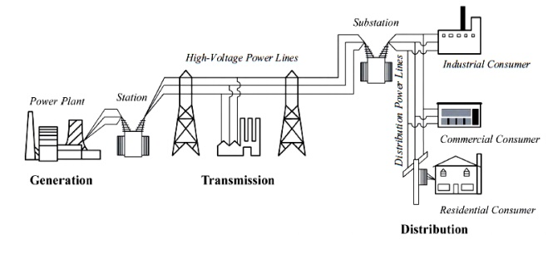

Fig 1.1 Structure of power system

This project mainly focuses on the highly demanded electrical distribution system component called a Ring Main Unit, which is employed to transform the distribution network into a robust, reliable and enhanced flexible switching operation.

A Ring main unit (RMU) is a Medium Voltage Switchgear that is used in power distribution networks and is designed to provide a cost-effective and safe electrical supply. Refer figure 1.3 for the general arrangement. It is used in-ring main electrical power distribution systems to provide a continuous power supply to the customer by shifting sources in event of any emergency or repair on the primary source and provide protection against faults and overloads. The RMU is usually installed in a switchgear cabinet and is connected to the distribution system by a bus bar system. It consists of several components, such as circuit breakers, relays and other control devices. The RMU can be used to control and protect the power supply to the distribution network, as well as to provide power to the end user.

The ring main unit is having a flexible combination made up of 3 to 5 total switch boxes to satisfy the power supply needs of various power distribution network junctions. The switch uses SF6 gas for executing load break operation.

The main function of the ring main unit (RMU) is to link the multiple feeder network. This helps to increase the stability of the power supply i.e. the loop function of ring main network.

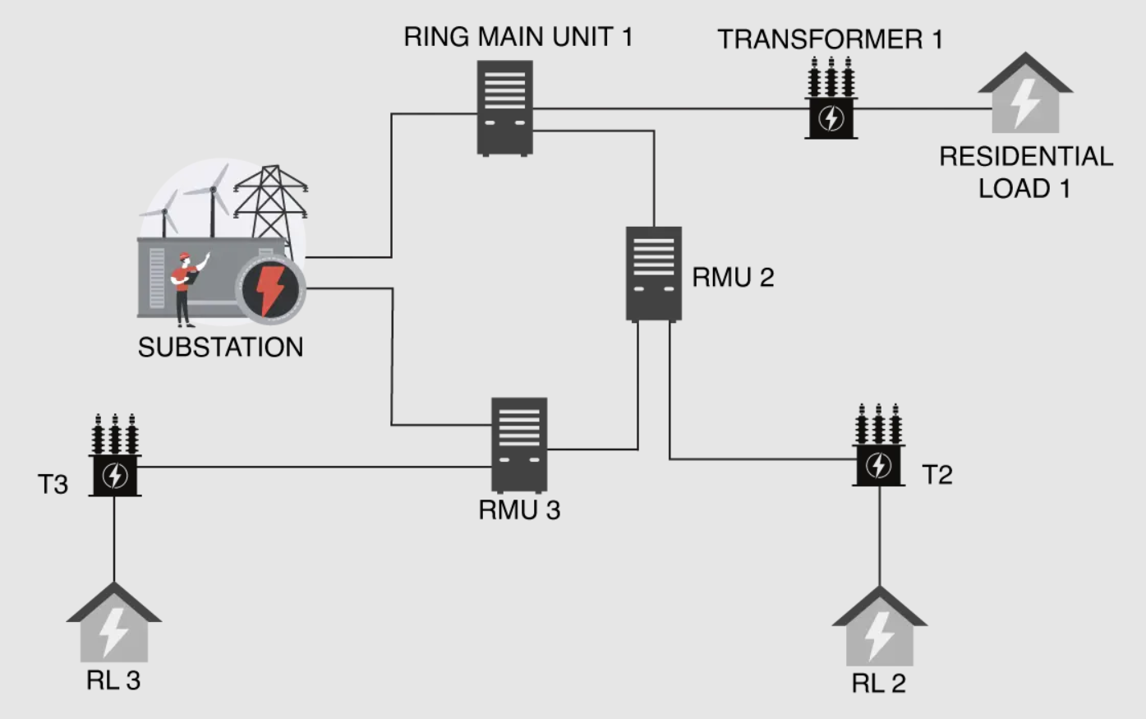

Fig 1.2 Ring Main Unit Employed in Distribution Network

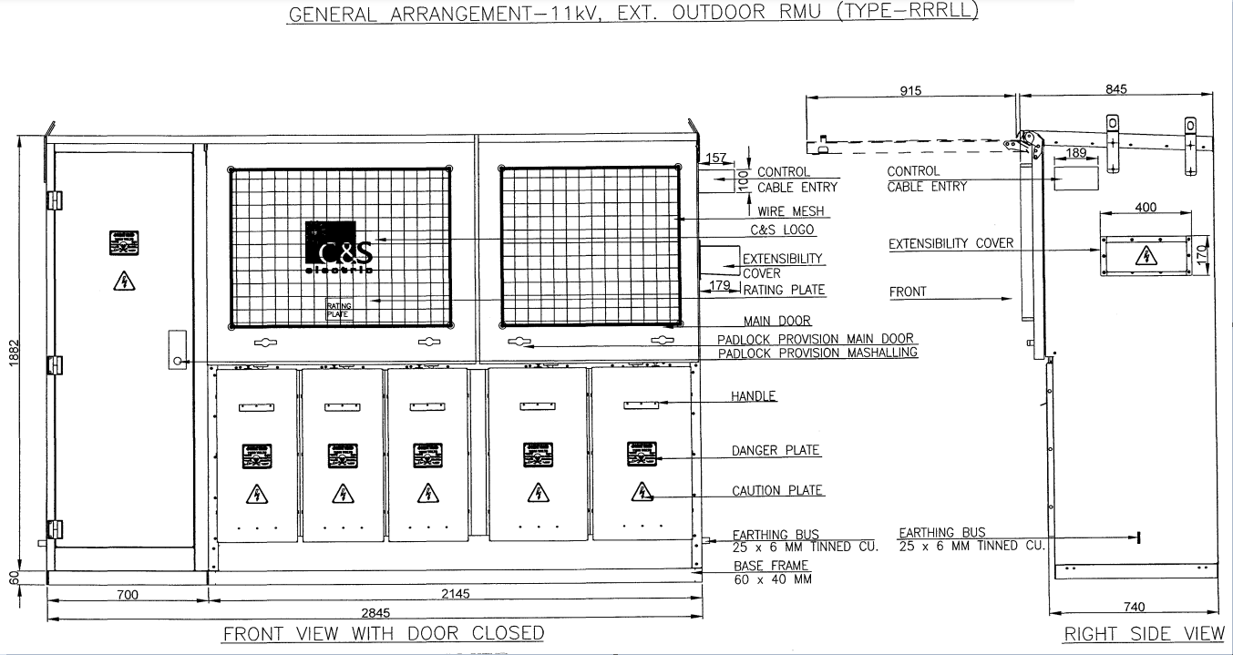

Fig 1.3 General arrangement of 11KV outdoor Ring main unit

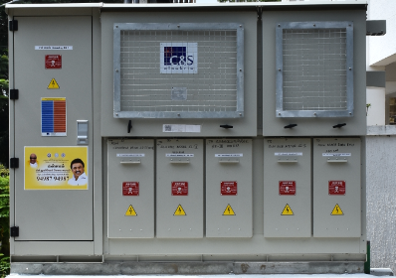

Fig 1.4 Front View of Ring main unit

**1.2. OBJECTIVE OF EMPLOYING RMU IN DISTRIBUTION NETWORK**

The main objective of the project is to install RMU (Ring Main Unit) in the electrical power distribution network is to provide a safe, reliable and efficient way to switch, protect and control the distribution system i.e., easy make and break of the network, fault finding in the network, Control and protection of the load network.

The Ring main units are used to isolate the faulty portion of the feeder network, taking care of protection of the equipment and to maintain the continuity of power supply to customers. The RMU provides a high degree of safety and reliability, and it is easy to install, maintain and operate.

Ring main units also reduce the need for manual intervention by linemen, as they can be programmed to automatically switch to a backup power supply in the event of a power outage. It can also be controlled from substation itself by employing Supervising control and data acquisition (SCADA) System by inbuilt Feeder remote terminal unit (FRTU) provision which used to analyze the system functioning with the help of multifunction transducers by Modbus communication channel and transfers the real time data to control center. The controller makes decision based on the data obtained from the FRTU.

During rainy seasons, it is very difficult for electrical distribution departments to maintain continuous power to utilities with conventional operating AB switches and jumpers. However, by employing RMUs in the distribution network, it is a risk-free job for the electrical distribution departments to oversee the operation and maintenance of the feeder network.

**1.3. RING MAIN UNIT FUNCTION**

The Ring Main Units (RMU) are electrical cabinets used in the power distribution network for various purposes, such as input power switching for transformer stations and outgoing feeder networks. They are equipped with a circuit breaker and relays that can enhance their capacity to protect selectively, prevent the transformer's surge current from operating inappropriately, and detect phase-to-phase fault currents and modest earth intensity. Compared to medium voltage explosives, they offer more protection.

The main function of Ring main unit in distribution network are:

* **Circuit control**: It provides reliable and safe switching and protection of electrical circuits.
* **Isolation**: It isolates the faulty section from the remaining circuit.
* **Protection**: It safeguards the circuit against the ground-fault current, short-circuits current fault, and overload.

The Ring main units are mainly employed in underground cable distribution network at the load connection and junction points of ring main type distribution network. In the event of any fault in the feeder branch network ring main units finds application to disconnect the faulty section from the rest of the operating feeder network. The said operation can be done either manually or remote operation by employing smart grid communication through SCADA system. The ring main units facilitate monitoring of the electrical network and provide control over the system by the application of Feeder remote terminal units. Ring main units support expansion of the electrical network and facilitate networking with other systems.

**1.4. SINGLE LINE DIAGRAM OF RING MAIN UNIT**

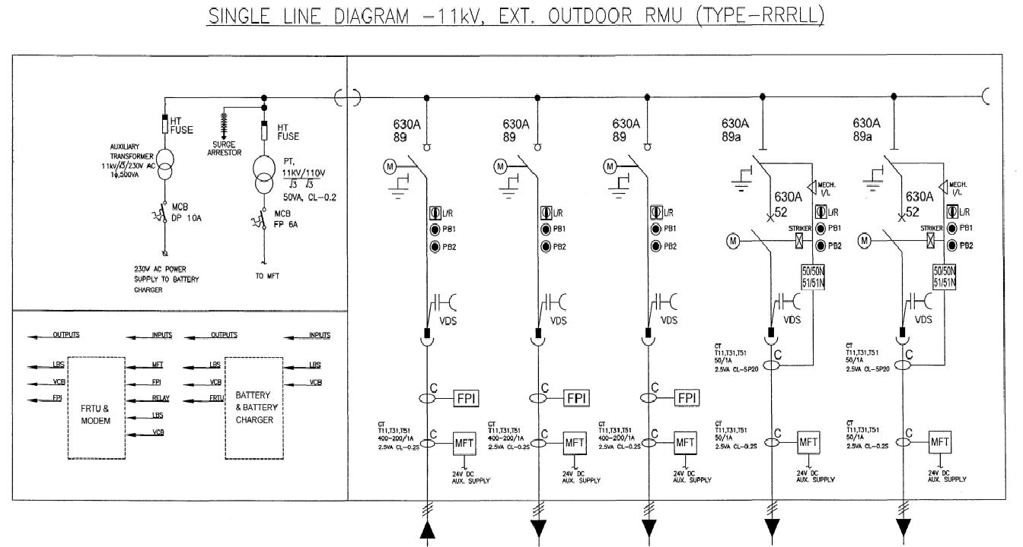

Fig 1.5. Single line diagram of Ring main unit (SLD)

The single line diagram of a ring main unit in the figure 1.5 covers the entire components such as Multifunction transducers, Current transformer, Potential transformer, Auxiliary transformer, Bus bars, Voltage presence indication system, Load break switches, Circuit breakers, cable compartments, fuses, FRTU, Battery and battery charger placed positions.

**1.5. SYMBOLS OF COMPONENTS**

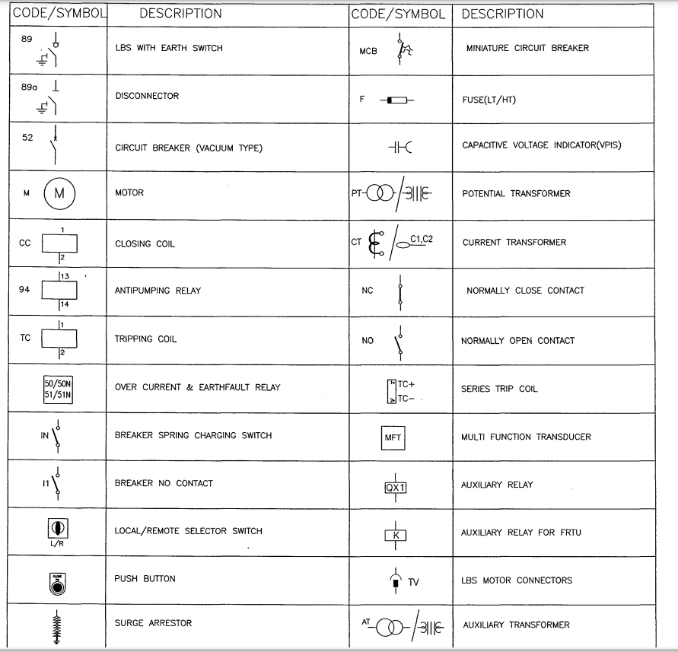

Fig 1.6 Symbols of components in ring main unit

The symbols and components that are mentioned in the ring main unit structure is mentioned in the above figure 1.6. All these symbols are present in the ring main unit at the specified places respectively.

**1.6. GENERAL SPECIFICATION**

1. All the dimensions are in mm.
2. System:

I. Voltage : 11KV

II. Highest System Voltage : 12KV

III. Phase : Three

IV. System Current : 630A

V. Frequency : 50HZ

VI. STC Rating : 21KA/3 sec

1. Construction:

I. The RMU shall be Outdoor type with extensible

II.The RMU shall be fabricated with

* + - 1. Tank :3 mm Steel
      2. Structure :2 mm G.I

1. Degree of protection :

I. RMU with main door closed -IP 54

II. RMU with main door open -IP 41

III.SF6 Tank -IP 67

1. Cable entry shall be from bottom.
2. RMU Shall be painted using Polyurethane based powder paint RAL-7032.
3. Paint thickness: 150 micron.
4. Control wiring shall be done using 1.1KV grade PVC insulated
5. Copper earth flat

I. Main bus : 34x08mm

II. Earth Bus : 25x05mm

1. Ferrules to be suffixed with LBS and VCB numbers.

**1.7. TYPES OF RMU**

Ring main units (RMU) are categorized into two types based on the place of installation:

1. Indoor Type
2. Outdoor Type

**a. Based on the structure**:

* Extensible
* Compact

**b. Based on the kind of arc stamping in the gas chamber:**

* Electrical insulation cabinet in an air environment
* Electrical insulation cabinet in a vacuum environment
* Electrical insulation cabinet in SF6 gas environment

**c. Based on the voltage level:**

* 11KV Voltage level
* 24KV Voltage level
* 36KV Voltage level

The following types of combination are available in the market:

Table: 1.1. Combination of ring main unit

|  |  |  |
| --- | --- | --- |
| **Sl.no** | **Type** | **Combination** |
| 1 | 3-way-11KV RMU | RRR |
| 2 | RRL |
| 3 | 4-way-11KV RMU | RRRR |
| 4 | RRRL |
| 5 | RRLL |
| 6 | 5-way-11KV RMU | RRRRR |
| 7 | RRRRL |
| 8 | RRRLL |
| 9 | RRLLL |
| 10 | 6-way-11KV RMU | RRRRRR |
| 11 | RRRRRL |
| 12 | RRRRLL |
| 13 | RRRLLL |
| 14 | RRLLLL |

Here,

R Stands for-Load break switch for Ring main feeder

L Stands for-Circuit Breaker for Distribution Transformer

**CHAPTER -2**

**COMPONENTS OF RING MAIN UNIT**

The main components of Ring main unit are listed below:

1. Load break switch (LBS)
2. Circuit breaker
3. Current Transformer (CT)
4. Potential Transformer (PT)
5. Over Current and Earth Fault Relay
6. 24V Battery Charger with Battery
7. Auxiliary Transformer
8. Voltage presence Indication System
9. Feeder remote terminal unit (FRTU)

The scope of feeder remote terminal unit in automation of distribution is emerging in future. In past the ring main unit are manufactured without including feeder remote terminal unit. But, in present officials are focused in smart power distribution leads to the rise of feeder remote terminal unit usage. So, the feeder remote terminal units are placed in built with the ring main unit in a dedicated compartment. In this project, we discussed feeder remote terminal unit in chapter 5.

**2.1 LOAD BREAK SWITCH (LBS)**

A load break switch (LBS) is a switching component used in a ring main unit (RMU) to isolate a section of the feeder distribution system for maintenance or fault repair. It can be operated remotely or locally to provide a safe means of interruption. It helps to reduce the risk of an electrical fault occurring on the system. The LBS is designed to open and close the circuit in a controlled manner, allowing current to safely make a break operation.

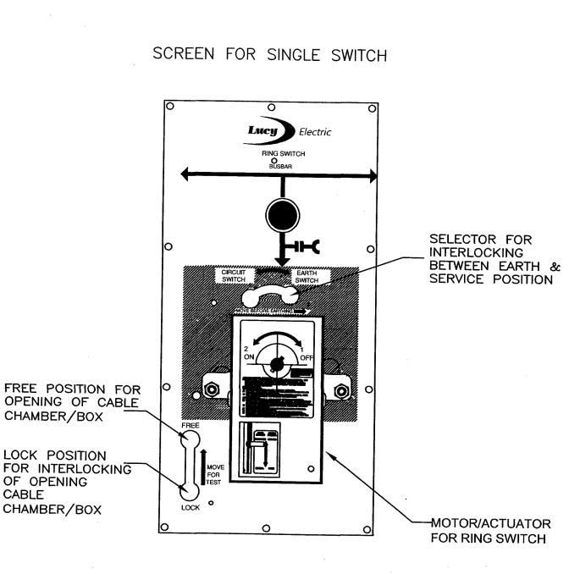

Fig 2.1 Front view of Load Break Switch

The load break switch in RMU in figure 2.1 allows the system to be safely operated during maintenance by locking the earth selector switch, thus tending the ring main feeder section to be earthed during the entire maintenance or rectification period.

**2.2 CIRCUIT BREAKER**

A circuit breaker is an electrical safety device designed to protect an electrical network from damage caused by overload or short circuit. Circuit breakers can be manually operated or automatically operated, and they are available in various sizes based on their application.

Circuit breakers are designed to disconnect an electrical circuit in the event of an overload or short circuit current occurring in the system. Its basic function is to interrupt the current flow after fault is detected.

"The circuit breaker is the great equalizer: it trips when the amount of power demanded of it is too great, regardless of whether it's a large corporation or a small family using it".

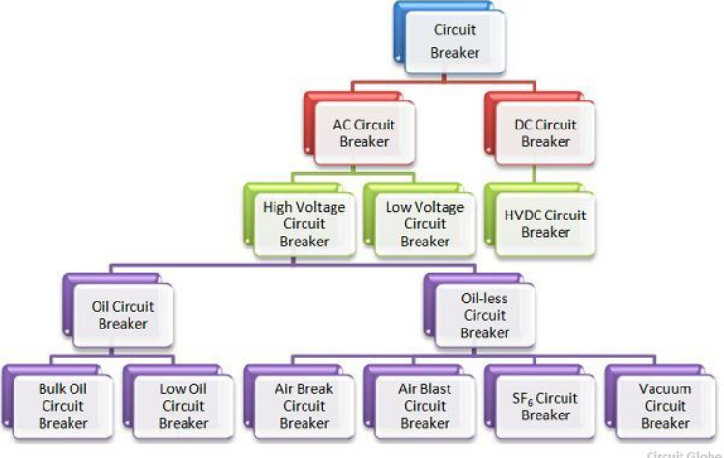

Fig 2.2. Types of Circuit breaker

**2.2.1 VACUUM CIRCUIT BREAKER**

A breaker which used vacuum as an arc extinction medium is called a vacuum circuit breaker(refer figure 2.3) . In this circuit breaker, the fixed and moving contact is enclosed in a permanently sealed vacuum interrupter. The arc is extinct as the fixed and moving contacts separated in high vacuum. It is used for medium and high voltage applications. The vacuum circuit breaker is an essential component in power distribution networks and can be used in both distribution and transmission networks. It is a reliable and maintenance-free solution for effectively controlling, protecting and isolating electrical systems.

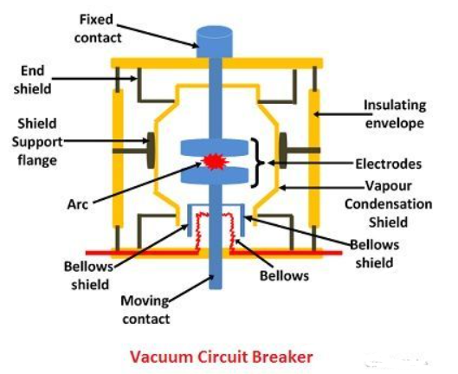

Fig: 2.3. Vacuum circuit breaker

**Auxiliary components for VCB:** 12KV, 21KA for 3Sec

* **A spring charge motor 24V DC**: A Spring charging motor automatically charges the spring mechanism for closing the circuit breaker and also recharges the spring mechanism when the circuit breaker is on the ON position.
* Closing Coil 24V DC
* Open Coil 24V DC
* Current terminals
* Interlocking System

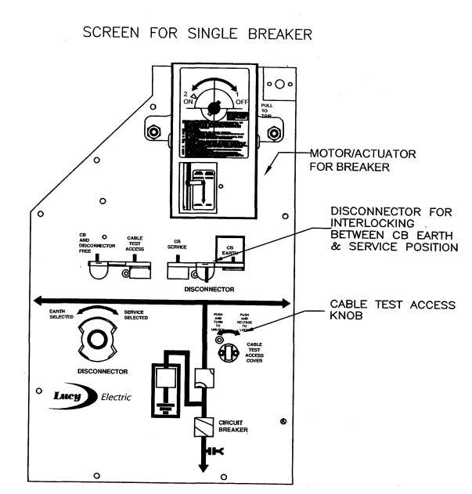

Fig: 2.4. Front view of Circuit breaker in Ring Main Unit

**2.3. CURRENT TRANSFORMER (CT)**

A current transformer (CT) is a type of instrument transformer that is used to measure magnitude of current in an electrical network. It works on the principle of electromagnetic induction and produces a current in its secondary winding proportional to the current flowing in its primary winding. The primary winding is connected in series with the line carrying the current to be measured, while the secondary winding is connected to a measuring instrument such as an ammeter. The current transformer (CT) is used to provide a safe and convenient means of measuring current in high voltage circuits. It also provides isolation between the measuring instrument and the line being measured.

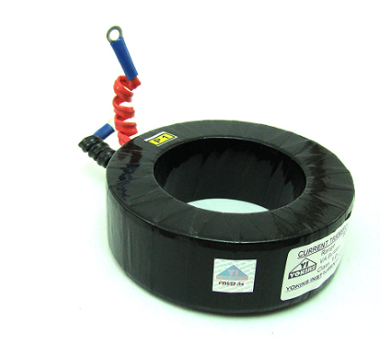

Fig 2.5. Current Transformer Used in RMU LBS

It works by taking an input current, usually from the main power line, and outputting a much lower current, typically 5A or 1A.

* In RMU, Current Transformers are designed with a range of 400/1A to 200/1A and they are limited to metering purposes in LBS.
* **The Ratio of CT** is defined as the ratio of the amount of current flowing through the primary winding to the amount of current flowing through the secondary winding.

**Types of Current Transformer are:**

* **Window Type**: These transformers are designed to be mounted on top of a power distribution line, with the primary winding wrapped inside the secondary winding.
* **Ring Wound Type:** These transformers are designed to be mounted inside an electrical panel and are commonly used in cables, bus bars and transformer bushings.
* **Bushing Type:** These transformers are designed to be mounted directly into a power line, using a special type of bushing
* **Split Core:** These transformers are designed to be installed without the need of disconnecting any power lines. The split core design makes it easier to install and remove the transformer without disrupting any existing wiring.
* **Rogowski Coil:** These transformers are designed to measure the AC current in a power line, using a non-invasive method. The Rogowski coil uses an electromagnetic field to measure the current without requiring any physical contact with the power line.

In RMU LBS Section is designed with **Ring type** CT shown in figure 2.5 because they are designed to fit around the cable bars, making them simpler, more cost-effective and its design allows for easier installation and maintenance.

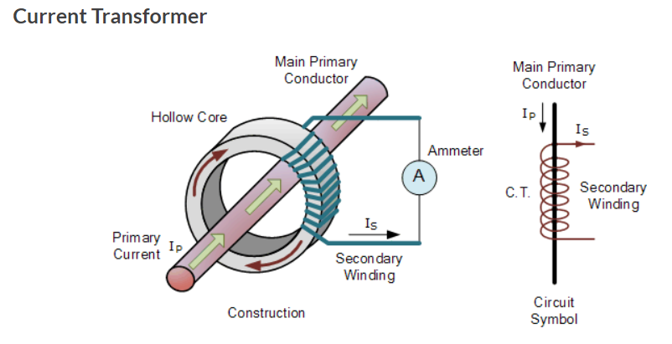

Fig 2.6. Current Transformer arrangement

**2.4. POTENTIAL TRANSFORMER (PT)**

A potential transformer (PT) is a device used to measure the voltage of an AC electrical system. It works by stepping down the voltage of the system to a level that can be safely handled and measured by a standard digital multimeter or voltmeter. Potential transformers are commonly found in electrical substations, factories, and other large-scale applications. The PT is often used in conjunction with current transformers (CTs) to measure the voltage and current of a system.

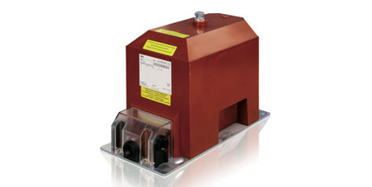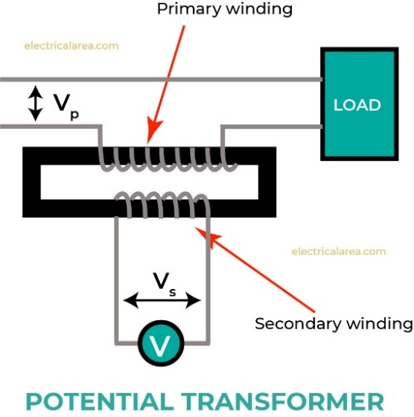

* It consists of two coils of insulated wire wound around an iron core.
* The primary coil is connected to the high voltage, while the secondary coil is connected to the low voltage.
* The ratio between the number of turns in primary and secondary coils determines the voltage transformation ratio.
* It helps to isolate measuring instruments from the high voltage, which prevents damage and injury.
* The accuracy of the potential transformer is determined by its ratio and the accuracy of its components.
  1. **OVER CURRENT AND EARTH FAULT RELAY**

A relay is an automatic device which senses an abnormal condition of electrical circuit and closes its contacts. These contacts in turns close and complete the circuit breaker trip coil circuit hence make the circuit breaker tripped for disconnecting the faulty portion of the electrical circuit from rest of the healthy circuit.

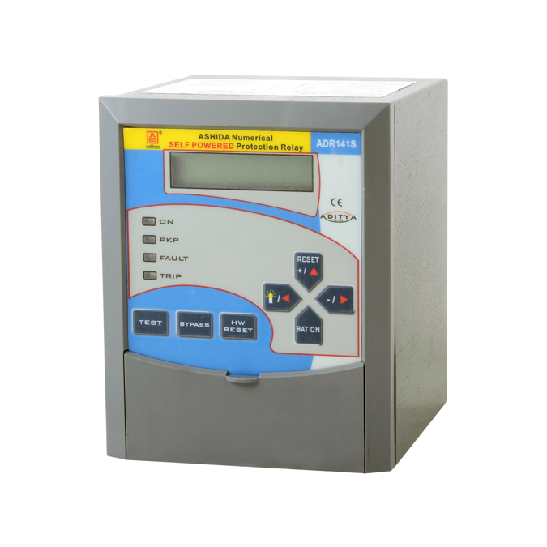

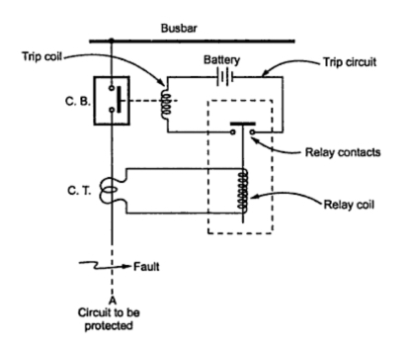

Fig: 2.9 Relay Circuit with C.B

Fig 2.8 Relay front view

**2.5.1. Earth Fault Protection**

Earth fault protection is a type of protection relay used to detect and protect against earth faults in power systems. It works by detecting any difference in potential between ground and the system. If the difference exceeds a predetermined value, the relay trips the circuit breaker, isolating the faulted circuit. This helps to prevent damage to the system and reduce the risk of electric shock.

**2.5.2. Over Current Protection**

Overcurrent protection is a type of protection relay that is used to protect electrical systems and components from damage due to excessive current. They are used to detect overloads and short circuits in electrical systems and circuit breakers. Overcurrent protection relays can be either electromechanical or solid-state depending on the application. They can be used to provide both instantaneous and time-delay protection.

**Over Current Relay gives protection against:**

* Phase Faults
* Earth Faults
* Winding Faults

**Rating:**

* **The voltage rating** of the overcurrent protective device must be at least equal to or greater than the circuit voltage. The overcurrent protective device rating can be higher than the system voltage but should not be lower
* **The ampere rating** of a overcurrent protecting device normally should not exceed the current carrying capacity of the conductors As a general rule, the ampere rating of a overcurrent protecting device is selected at 125% of the continuous load current.

**2.5.3. Types of Over Current Relay:**

1. Instantaneous overcurrent relay

2. Definite time overcurrent relay

3. Inverse time overcurrent relay

4. Directional overcurrent relay

**1.** **Instantaneous overcurrent relay:**

The relay operates instantaneously when the current reaches a predetermined value as shown in figure 2.10

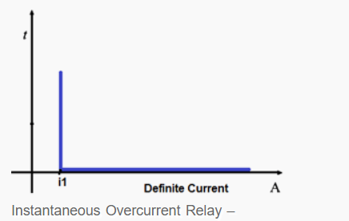

Scale: On X-axis Current in amperes, On Y-axis time in milli seconds

* The relay operates in a definite time when current exceeds its pickup value.
* It operates with respect to the current magnitude preset value.
* Coordination of instantaneous relay is based on the fact that the fault current varies with the position of the fault because of the difference in the impedance between the fault and the source.
* It operates in 0.1 or less
* It finds application in outgoing feeders.

1. **Definite time overcurrent relay:**

In Definite time overcurrent relay in figure 2.11, two conditions must be satisfied for operation (tripping), current must exceed the setting value and the fault must be continuous at least a time equal to time setting of the relay.

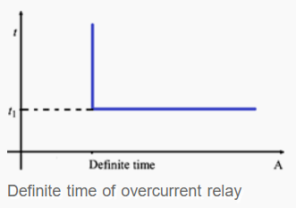

Scale: On X-axis time in milli seconds, Current in amperes

Fig 2.11 Behavior of definite time overcurrent relay

* For operation of definite time overcurrent relay operating time is constant.
* Its operation is independent of the magnitude of current above the pickup value.
* It has pickup and time dial settings, desired time delay can be set with the help of an intentional time delay mechanism.
* Constant tripping time independent of infeed variation and fault location.
* Easy to coordinate.
* It finds appli**catio**n in outgoing feeders and bus couplers with adjustable time delay setting.

**3.** **Inverse time overcurrent relay:**

In Inverse time overcurrent relay detects when a current exceeds a preset value and respond by opening the circuit. The time it takes for the relay to respond is inversely proportional to the magnitude of the current. This means that the higher the magnitude of current, the faster the relay will open the circuit. These relays are widely used in power systems to protect against overloads, short circuits, and ground faults. It is standardized to inverse, very inverse and extremely inverse types as in figure 2.12.

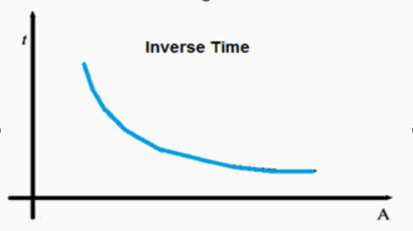

Scale: On X-axis Current in amperes On Y-axis time in milli seconds

Fig 2.12 Behavior of Inverse time overcurrent relay

* It operates when current exceeds its pickup value.
* Operating time depends upon the magnitude of the current.
* It gives inverse time current characteristics at lower values of fault current and definite time current characteristics at higher values.
* 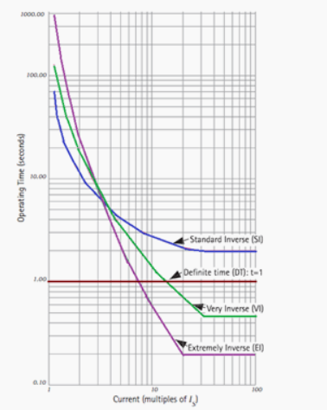Widely used for the protection of the distribution feeder lines.

Fig 2.13 Behavior of definite time overcurrent relay

Based on the inverseness, it has four different operating characteristics which are highlighted in the above graph in figure 2.13.

**4.** **Directional overcurrent relay:**

When the power system is not radial, an overcurrent relay may not be able to provide adequate protection. This type of relay operates in on direction of current flow and blocks in the opposite direction.

In directional overcurrent relay three conditions must be satisfied for its operation: current magnitude, time delay and directionality. The directionality of current flow can be identified using voltage as a reference of direction.

* It is simple and inexpensive.
* Very often the relays do not need to be directional and hence no PT supply is not required.
* It finds application for transformer and feeder line protection.

**2.6. 24V BATTERY CHARGER WITH BATTERY**

The main function of Battery is used to provide DC power supply to the RMU Components such as Circuit breaker, Relay and Load break switch disconnector.

A battery charger, or recharger, is a device used to put energy into a secondary cell or rechargeable battery by forcing an electric current through it.

Rating: 26Ah Battery and charger, input-230V AC, Output-24V DC

**Ampere hour:**

An ampere hour (abbreviated Ah, or sometimes amp hour) is the amount of energy charge in a battery that will allow one ampere of current to flow for one hour.

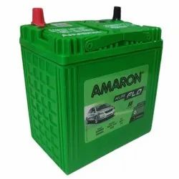

Fig 2.14. Ampere hour Battery

**2.7.** **AUXILIARY TRANSFORMER**

An auxiliary transformer in figure 2.15 is a single-phase step-down transformer used to connect the primary winding of the transformer to the bus bar and earthing bar of a rated voltage of 11KV/RT3, and to connect the secondary winding to the utility of the ring main unit with a rating of 110V/RT3. The transformer has a power rating capacity of 500VA.

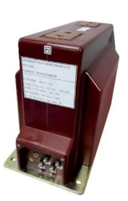

Fig 2.15. Auxiliary Transformer

**2.8. VOLTAGE PRESENCE INDICATING SYSTEM**

The Voltage Presence Indicating System in figure 2.16 is a permanent monitoring system for 3-phase line voltages ranging from 3 kV to 52 kV/ 50-60 Hz, typically used in ring main unit. It is complied with the IEC 61958 (2000) international standard, and is designed to be installed on the front side of the RMU. The system uses flashing LED diodes to provide a bright red signal for each phase of the 3-phase system network and draws its power directly from the individual MV system lines using capacitive coupling electrodes. The system requires no external power or maintenance, and is designed for indoor use in standard environments. It also includes built-in test points to check the phase sequence, a surge arrester for protection. Maximum operating current of VPIS is 2.5 µA.

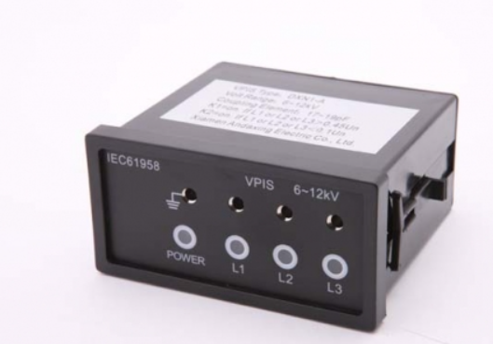

Fig 2.16. Voltage presence indication system

**2.9 FAULT PASSAGE INDICATOR (FPI)**

Fault Passage Indicator (FPI)designed to detect and indicate Earth fault on a cable system, in RMU networks with one input /open ring arrangement. This unit will indicate a fault condition when current is detected above set trip current settings. A short-range radio interface shall be embedded in this Fault Passage Indicator to allow it to communicate with the GSM/GPRS communication interface as shown in figure 2.17.

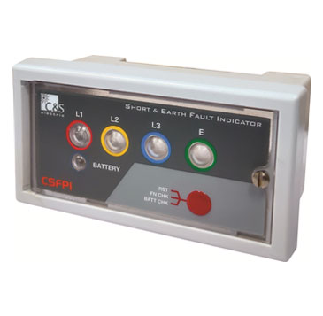

Fig 2.17. Fault Passage Indicator

**CHAPTER -3**

**PRE-COMMISSIONING TESTING OF RING MAIN UNIT**

The Pre-commissioning Test for Ring main unit is conducted to ensure the healthiness and performance of the equipment.

**3.1.** **REQUIREMENTS OF TESTING KITS** **AND INSTRUMENTS**

Table: 3.1. List of testing and instruments

|  |  |  |
| --- | --- | --- |
| **S.No** | **Testing Kit** | **Range** |
| 1 | Contact resistance kit with test leads | 0 – 2000milliohm |
| 2 | Three pole timers with test leads | 0 – 99sec |
| 3 | Insulation Resistance test | 0-5Kv |
| 4 | Primary Injection test kit with test leads cables | 0-2000A |
| 5 | High voltage transformer with test leads | 0-5Kv |
| 6 | Digital Multimeter | - |
| 7 | Clamp meter | 200mA-2000A |

**3.2.** **TYPES OF TESTS**

1. Insulation Resistance Measurement Test

2. Trip Coil/Close Coil Resistance Measurement of CB

3. Opening/Closing Time Measurement Test of CB

4. Main Circuit Contact Resistance Measurement Test for CB

5. Pre commissioning Tests for Switchgear CT

6. Pre commissioning Tests for Switchgear PT

7. Insulation resistance test for bus bar

8. Contact resistance test for bus bar

9. High voltage test for bus bar

10. Pre commissioning test for protection relay

**3.2.1.** **Insulation Resistance Measurement Test**

Insulation Resistance Measurement Test is conducted to find the insulation resistance value of the equipment and ensure the healthiness of the equipment.

Insulation resistance measurements are used to verify the integrity of the electrical insulation of a system and indicate the presence of any leakage current.

The mentioned test is conducted to the load break switch (LBS) and circuit breaker (CB).

**Equipment Required:**

1. Insulation tester

**Test procedure:**

The test is performed by connecting the IR tester across the pole and earth combination of circuit breaker and load break switches respectively.

The reading should be above the manufacturer's specified minimum value and should be as close to infinity as possible. If the reading is below the specified value, then the insulation should be inspected and replaced if necessary.

Table: 3.2. Insulation resistance measurement test results

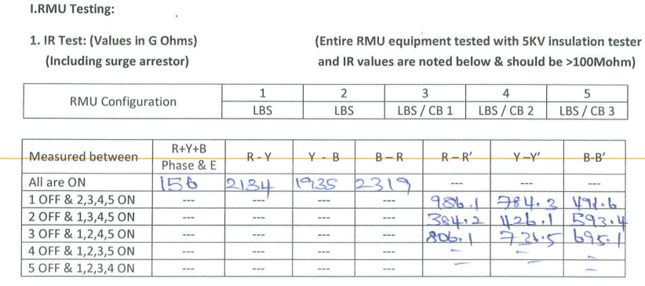

**3.2.2.** **Trip Coil/Close Coil Resistance Measurement of CB**

The Trip Coil/Close Coil Resistance Measurement is conducted to measure the value of trip coil and close coil resistance of the circuit breakers and compare them with the factory approved values.

**Equipment Required:**

1. Multimeter

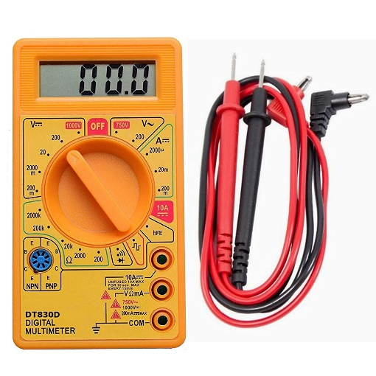

Fig 3.1 Multimeter

**Test procedure:**

To perform the test, the multimeter is set to resistance mode and it is connected across the trip coil and close coil. The noted reading should meet the manufacturer's specified value.

If the resistance is too high, the circuit breaker may not trip and close properly, which could lead to dangerous situations.

By measuring the resistance of the coils, it can be determined whether the circuit breaker is functioning properly.

**3.2.3. Opening/Closing Time Measurement Test of Circuit breaker**

The opening/closing time measurement test for a circuit breaker with single or three pole timer is a procedure used to assess the breaker's capability to open and close within the expected time.

**Equipment Required:**

Single / three pole timer

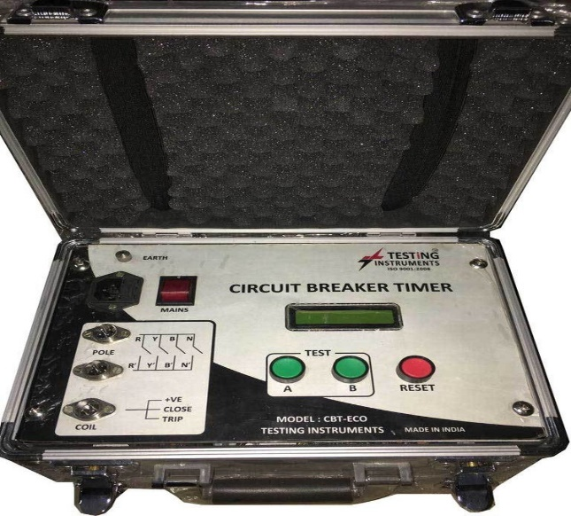

Fig 3.2. Timer Kit

**Test procedure:**

This test is conducted by connecting the circuit breaker to a power source and then measuring the time it takes for the contacts to open and close. The test results can be used to determine the breaker's performance and whether it meets the applicable standards. For single pole timers, the test is done by connecting the timer to the circuit breaker and measuring the time taken for the contacts to switch from open to closed. For three pole timers, the test is done by connecting the timer to each of the three poles of the circuit breaker and measuring the time taken for each of the three poles to switch from open to closed.

Table 3.3. Circuit breaker timing test results

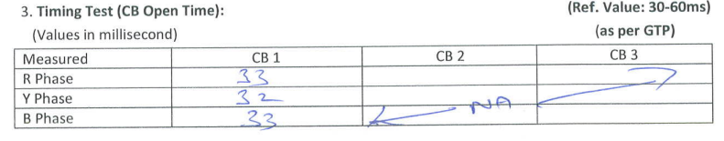

**3.2.4. Main Circuit Contact Resistance Measurement Test for CB**

The contact resistance measurement test is used to measure the electrical resistance between two contact points on a circuit breaker. This test is important to ensure that the circuit breaker is functioning properly and that the contacts are not excessively worn or corroded.

**Equipment Required:**

1. Contact resistance meter

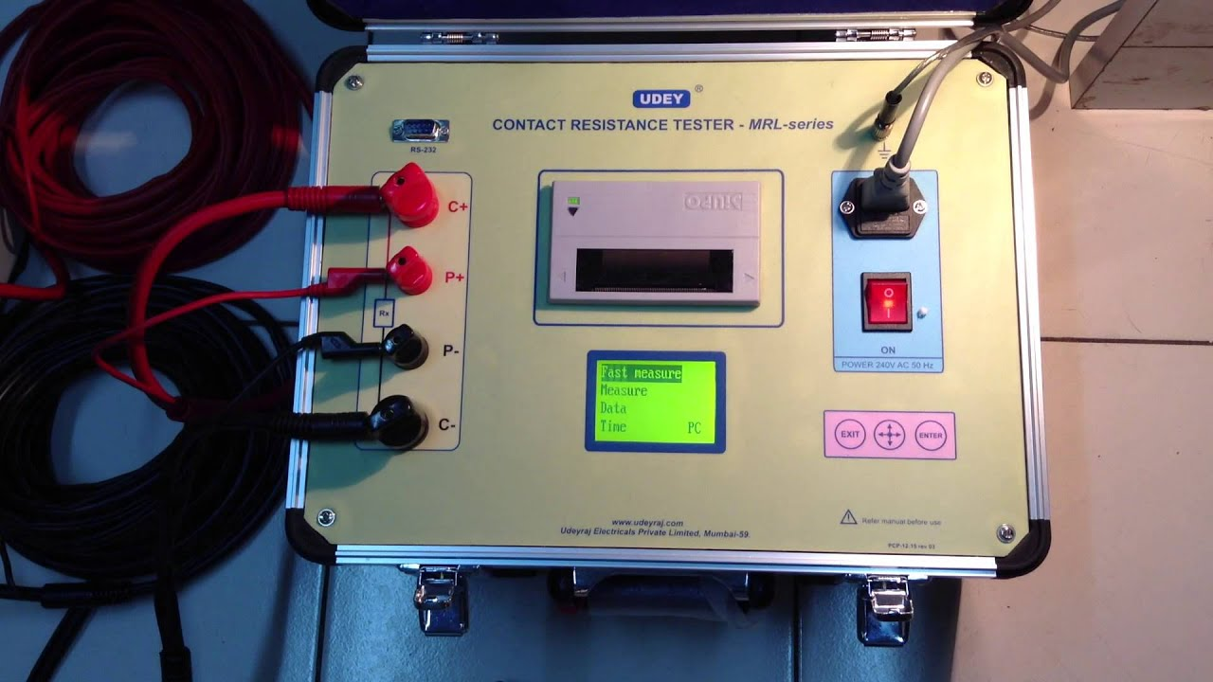

Fig 3.3. Contact resistance meter Kit

**Test procedure:**

To perform the test, the contact resistance meter is connected between the two contact points on the circuit breaker to measure the resistance value across them. The results of the test are then compared to the manufacturer's specifications to ensure that the contact resistance is within acceptable limits. If the contact resistance is too high, then the circuit breaker may not be able to carry the necessary current load and may need to be replaced.

Table: 3.4. Circuit breaker contact resistance measurement test results

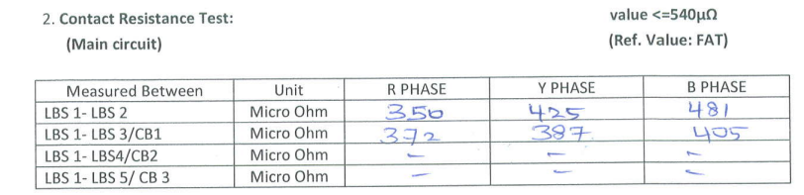

**3.2.5. Pre commissioning Tests for Switchgear CT**

The Pre-commissioning tests are conducted to ensure that the Switchgear CT functions correctly. These tests also help to identify any problems or defects that could lead to malfunctions and to confirm that the switchgear is correctly connected and configured to suit the application. These tests also ensure that the CTs are calibrated.

**Pre commissioning tests for CT are**:

**1.** **Visual Inspection**: This involves verifying nameplate ratings, inspect for physical damage/defects, verify wiring clearances, torque fastenings, required grounding/shorting, and single-point grounding.

**2.** **Insulation Resistance Test**: This is a test used to measure the resistance of the insulation between the phases and ground.

**3. Continuity Test**: This test measures the continuity of the circuit between the phases and also between the phases and ground.

**4. Polarity Test**: This test helps ensure that the CT transformer is correctly connected and the current is flowing in the correct direction.

**5. Primary injection Test** – To test the accuracy of the current transformer ratios.

**6. Knee Point Voltage Test** – To measure the ability of the CT to withstand high voltages.

**7. Contact Resistance Test** – To measure the resistance of the contact between the different parts of the CT.

**Testing Kit Required:**

Table: 3.5. List of Test kits required for CT testing

|  |  |  |
| --- | --- | --- |
| **S.No** | **Test Kit** | **Range** |
| 1 | Primary Injection Kit with test leads | 0-2000A / 5V (AIS)0-3000 / 5V (GIS) |
| 2 | High Voltage Transformer with test leads | 0 -5kV |
| 3 | Secondary injection kit with test leads | 0 – 100A |

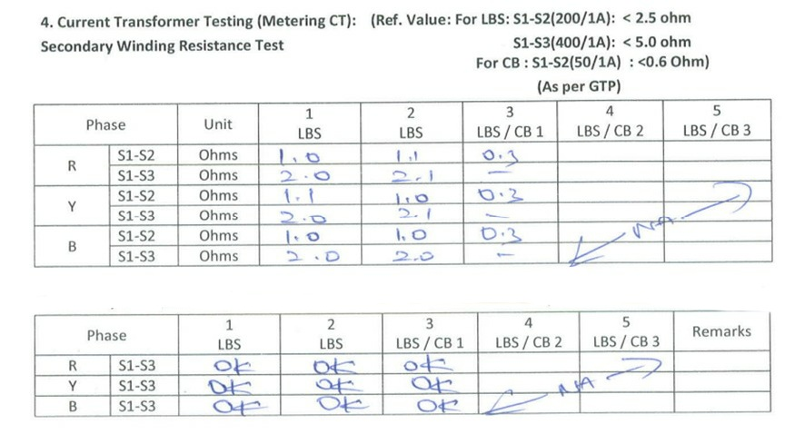

Table: 3.6. Pre-commissioning test results of Current Transformer

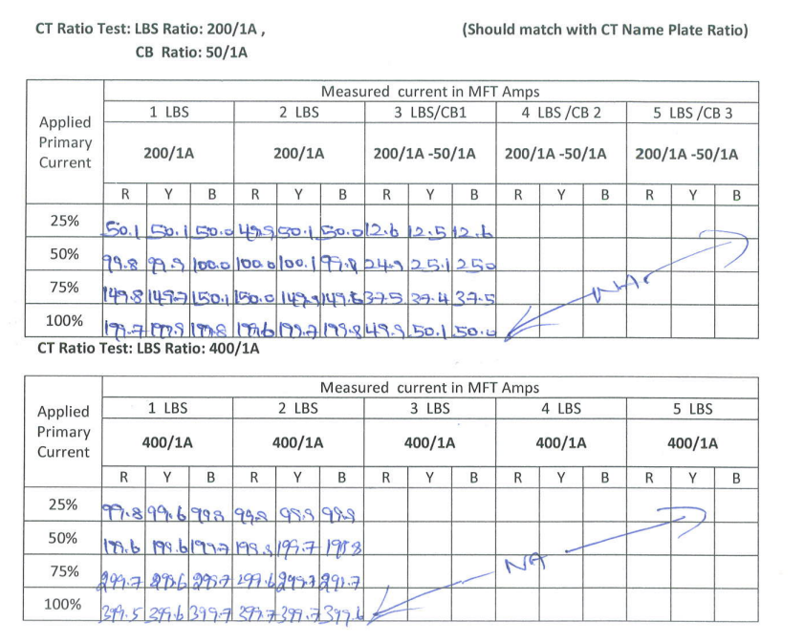

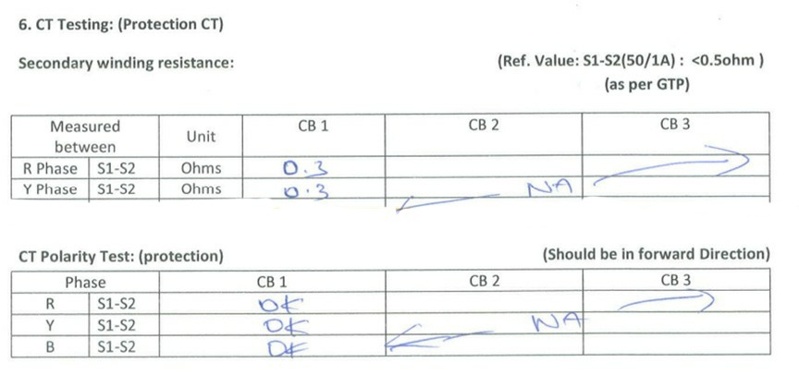

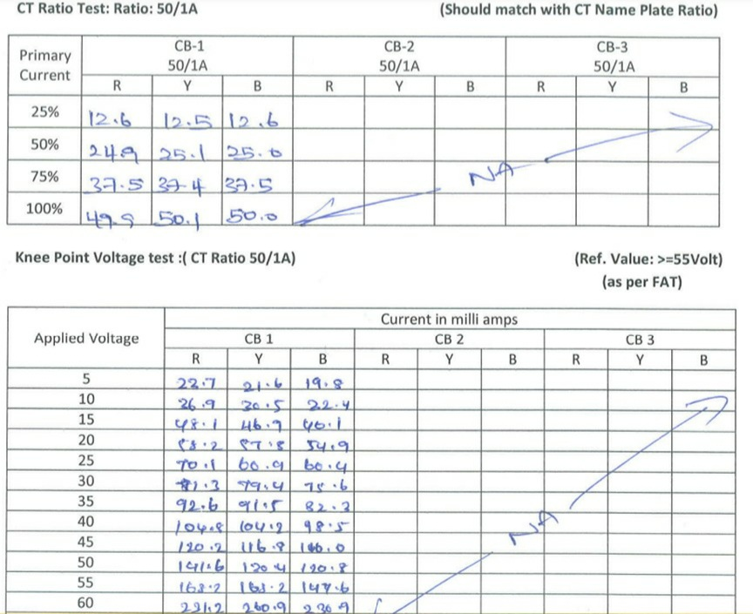

**3.2.6. Pre commissioning Tests for Switchgear PT**

The pre- commissioning tests to be conducted in systematic manner for Potential Transformers to ensure the healthiness and performance of the equipment.

**Pre commissioning tests for PT are**:

**1. Insulation Resistance measurement Test:** This test is conducted to ensure the insulation healthiness of the primary and secondary windings by measuring the insulation resistance value.

The Above test to be conducted at following points

1. Primary to Earth
2. Primary to Secondary
3. Secondary to Earth
4. Between Secondary Cores

**2. Continuity Test:** This test is done in order to ensure that the flow of power is not interrupted in between due to damages. This test assures that the flow of power is continuous**.**

**3. Secondary winding resistance test:** This test is mainly done in order to calculate the secondary winding resistance value and compare it with the factory test report and approve for use if test results are found satisfactory.

**4. Polarity test:** This test is done to find the polarity of the terminals and to ensure that the terminals are marked with correct polarity as required.

**5. Ratio test:** This test is conducted to calculate the values of turn ratio and compare it with specification as mentioned in vendor name plate details, then only it will be allowed for use.

Table: 3.7. Pre-commissioning test results of Potential Transformer

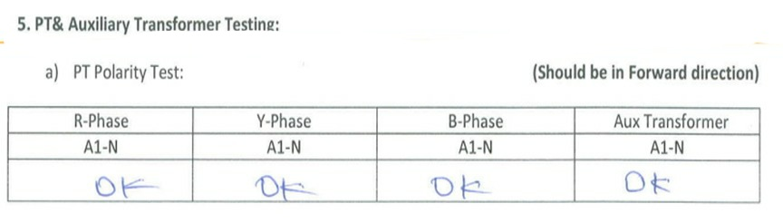

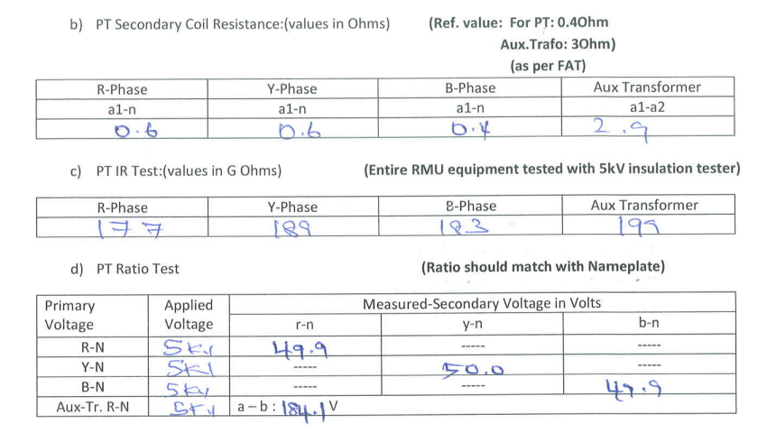

**3.2.7. Insulation resistance test for bus bar**

An insulation resistance test for bus bar is conducted to measure the resistance of the insulating material that separates the bus bar from other conducting paths.

The test is conducted by Insulation resistance Tester (IR Tester) at the following points:

a) Each phase and earth.

b) Between phases.

The higher the insulation resistance, the better the insulation of the bus bar.

**3.2.8. Contact resistance test for bus bar**

Contact resistance measurement of bus bar is an major testing process used to ensure the safety and reliability of Ring main unit. Contact resistance is measured to detect any loose or corroded connections, which may result unexpected electrical failure.

The contact resistance measurement process is done by using a specialized instrument known as a contact resistance meter.

The contact resistance meter measures the contact resistance between two points on the bus bar by passing some known current through the bus bar and measuring the voltage drop across the connection.

The resistance measurement is then compared against the manufacturer's specifications to ensure the bus bar is in proper working order. If it meets the specification as per requirement, it is certified to use for commissioning activity.

**3.2.9. High voltage test for bus bar**

The high voltage testing of bus bar is conducted to measure the strength of the insulation separates the bus bar from other conducting paths.

The test is mainly performed to ensure that the insulation of the bus bar is able to withstand the high voltage that is used in the system. In order to perform the test a **high voltage test kit** is required.

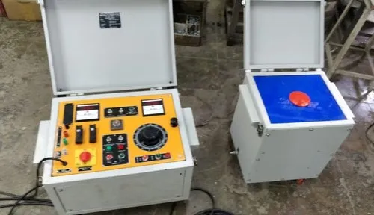

Fig 3.4. High Voltage test Kit

During the test, a high voltage is applied directly to the bus bar and the insulation is monitored to ensure that it can withstand the voltage without breakdown. If the insulation fails, the bus bar is replaced and the test is repeated.

Table: 3.8. High voltage test results of bus bar

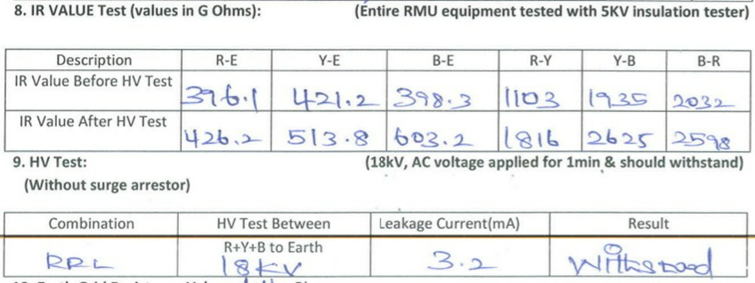

**3.2.10.** **Pre commissioning test for protection relay**

Pre-commissioning tests for relays are conducted prior to the commissioning of a Ring main unit. These tests are done to check the functionality of the relays and to make sure that it is properly configured and will function correctly in the event of a fault or abnormal conditions. The test also includes checking the accuracy of the time delay settings, checking the communication links between relays and the control system.

**Requirement of testing kits:**

Table: 3.9. List of testing kits for relay testing

|  |  |  |
| --- | --- | --- |
| S.No | Testing kit | Range |
| 1 | Relay test Kit | 0-25A, AC from single channel,250V Auxiliary DC,300V AC |
| 2 | Laptop with testing kit software and relay software |  |

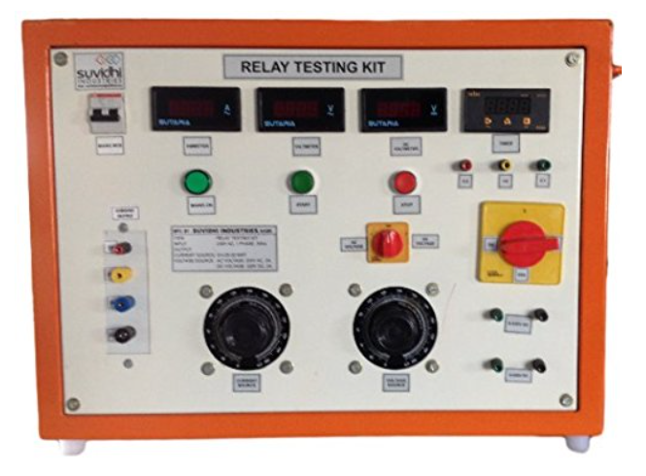

Fig 3.5. Relay test Kit

The fault current is measured by a current transformer (CT) and the system voltage is measured by a potential transformer (PT) at the time of the fault. The secondary of the CT and PT then send their proportional signals to the protection relay that controls the circuit breaker**.**

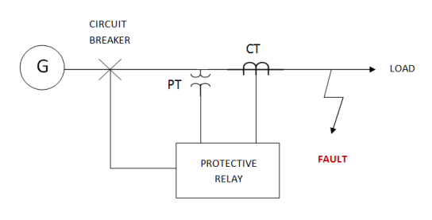

Fig 3.6. Basic protection scheme

Once these signals matched the relay’s operating condition, the relay will operate and issue a trip signal to trip the corresponding circuit breaker. Therefore, to test the relay whether it can perform properly and accurately by

* **Secondary current Injection test:**

The source of the relay's input current is the secondary side of the current transformer. To evaluate the accuracy of the relay's tripping, a comparable amount of current is given to the relay by test kit. This quantity of current can typically range from tens of milliamps to tens of amps.

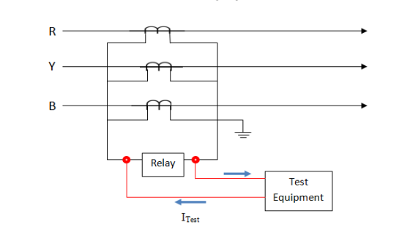

Fig 3.7. Secondary current injection test

To conclude that the relay is working properly, needs to analyze the results, and make sure all the measurements obtained from the test are within the acceptable range. If all the measurements are within the acceptable range, then the relay is likely working properly.

**Protection modes of relay are:**

* **Overcurrent protection:** It is used to protect electrical systems from overloads and short circuits. It works by detecting when the current in a circuit exceeds a certain limit, and then triggering a relay switch to disconnect the circuit from the power source.
* **Earth fault protection:** It is used to detect and prevent damage caused by earth faults in an electrical system. It works by detecting when the voltage on the earth conductor exceeds a predetermined threshold, and then triggers a relay switch to disconnect the circuit from the power source.

**Instantaneous protection:** It is used to detect and prevent damage caused by transients or momentary overloads in an electrical system. It works by detecting when the current in a circuit exceeds a certain limit for a very short period, and then triggers a relay switch to disconnect the circuit from the power source.

Table: 3.10. Pre commissioning test results of protection relay

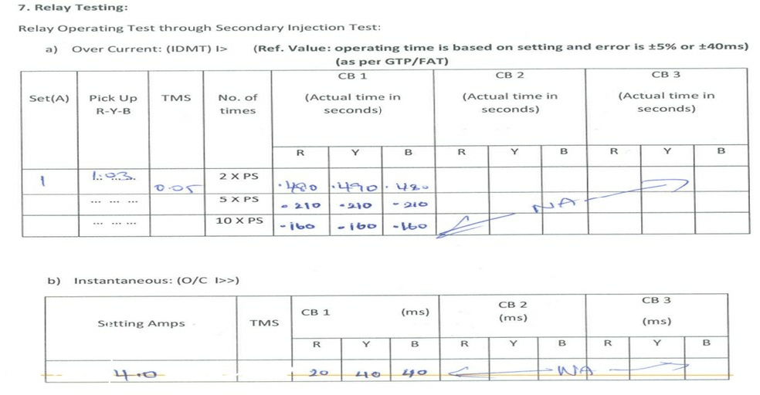

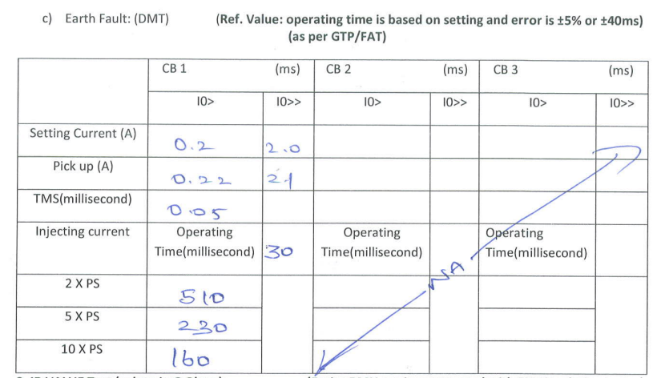

**CHAPTER - 4**

**INSTALLATION OF A RING MAIN UNIT**

**4.1.** **SURVEY**

Location Survey is the primary activity for installation of an RMU. Survey activity is being done by concerned electrical department officials with executing agency. During survey the following points need to be considered for hassle free executing the job.

* Requirement of RMU taken from the concerned operation and maintenance department.
* Sufficient area should be available for casting RMU and DTR Structure foundation.
* Clearance for the concerned land to be confirmed by local counsellors and electrical department.
* Location to be approachable for handling further activities.
* Combination of RMU to be finalized based on the incoming and outgoing feeders.

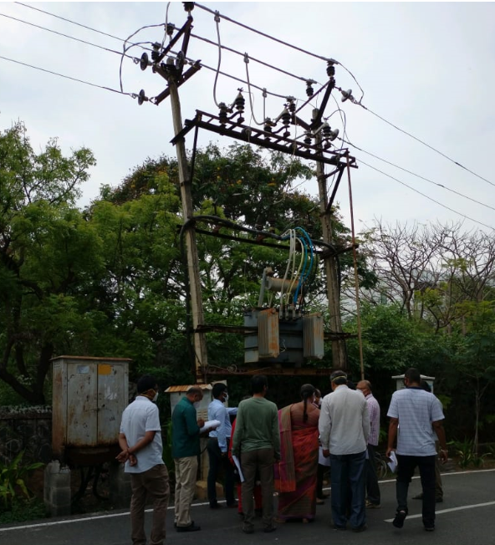

Fig 4.1. Survey activity

**4.2.** **CIVIL WORK**

Civil work related to constructing the foundation of ring main unit (RMU) involves excavating the allotted area for the foundation based on the given specification, removing the soil and debris, and preparing the area for PCC. After the area is prepared, a formwork is set up and the concrete is poured. The casted foundation is allowed to curing for 7 days before the ring main unit is installed.

* PCC will be done in the ratio of 1:4:8 (Cement: Sand: Blue Metal).The gravel shall be 40mm.
* RCC will be done in the ratio of 1:2:4 (Cement: Sand: Blue Metal).The gravel shall be 20mm.

Before commencing the excavation activity, the area should be checked with UG cable detector for checking the live cable presence in the area to be excavated. It gives the alarming sound if there is any live cables presence in its vicinity area.

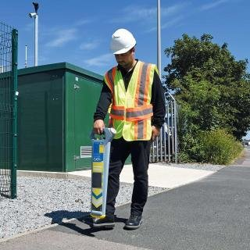

Fig 4.2.UG Cable detector practice

After confirming that the area is free from charged cable, then workmen are allowed to do excavation activity with insulated digging tools like crowbar and spade.

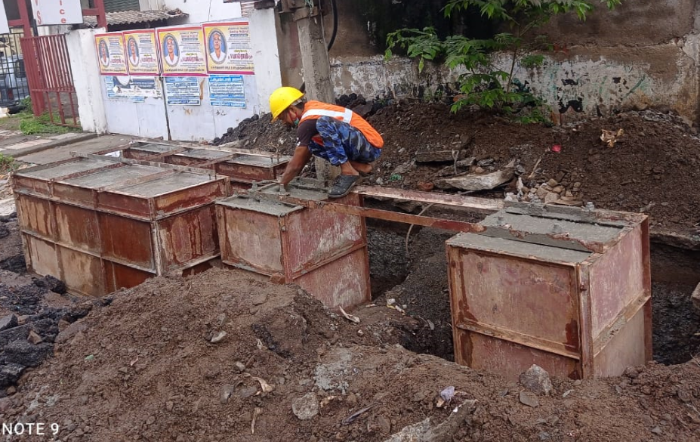

Fig 4.3. Formwork for RMU and DTR Structure foundation

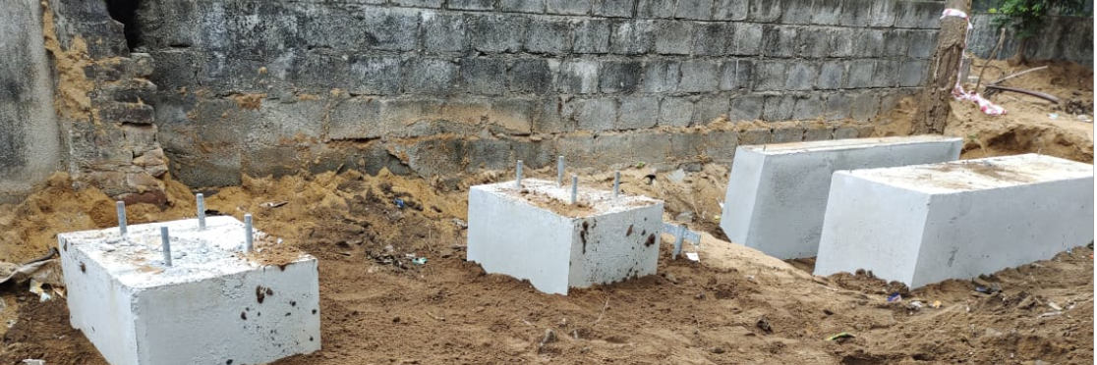

Fig 4.4RMU and DTR Structure Foundation

**4.2.1. Curing of RMU foundation**

Curing is involves in the application of moisture to the foundation, either through sprinklers or by flooding the area with water. As shown in figure 4.5 this should be done over a period of seven days to ensure that the foundation is properly set. In some cases, curing can be extended by adding a curing compound to the soil. This compound helps reduce the rate of evaporation and encourages the formation of strong, stable bonds between the foundation and the soil.

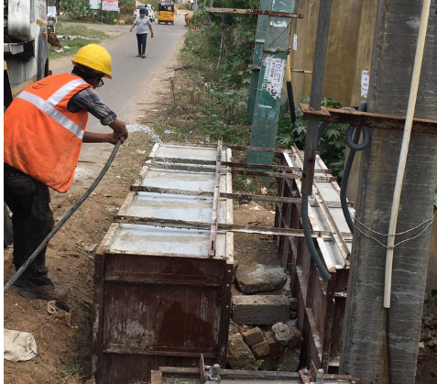

Fig 4.5. Curing of RMU foundation

**4.3.** **INSTALLATION OF RMU**

Once the foundation had completed its curing process, the RMU can be placed on it by engaging a 16T capacity hydra or Truck mounted crane and secured with anchor bolts. The bolts should be perfectly tightened and ensure a secure fit.

The alignment and level of an RMU needs to be checked before the nut and bolts are properly tightened.

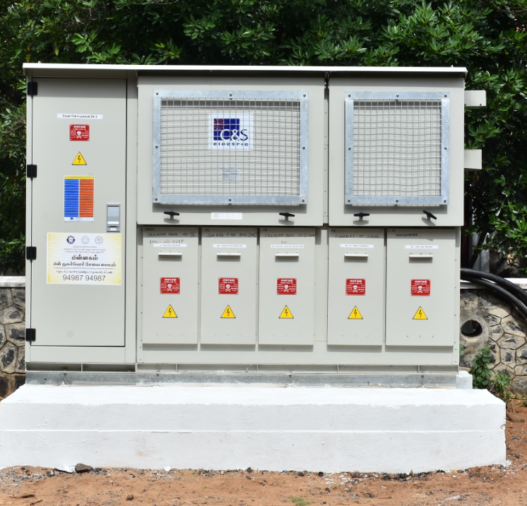

Fig 4.6. Front view of an RMU installed on foundation

**4.4.** **TESTING OF RMU**

The pre-commissioning test are carried out at site after erection of RMU on foundation. The competent testing team will be called for carrying out the tests which are previously discussed.

Testing engineer will certify the ring main unit if it passes the testing requirements and issues ready for use certificate for absorption of Ring main unit in feeder distribution network.

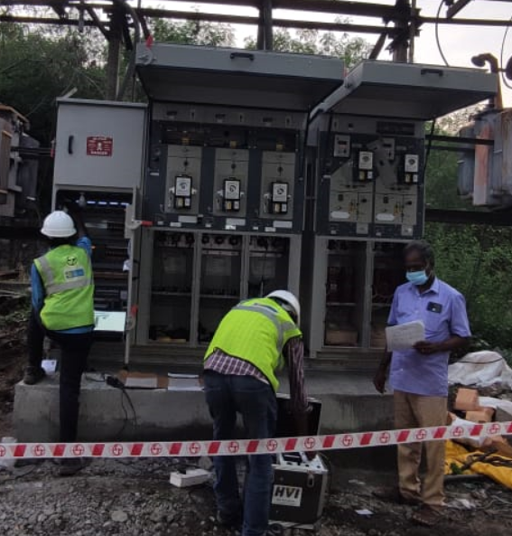

Fig 4.7. Testing Activity

**4.5****. COMMISSIONING OF RMU**

Commissioning is the last activity for energizing the ring main unit and imparting it into the distribution feeder network system for operation and control.

The commissioning activity is subdivided into various sub activities. They are:

* Dismantling of existing structure.
* Erection of new DTR Structure.
* Cable Termination
* Charging of Ring main unit.

**4.5.1. Dismantling of existing structure**

Existing structure is dismantled with hydra or Truck mounted crane operated by valid licensed driver. During dismantling activity the area should be properly barricaded for blocking unauthorized persons at the work area as shown in figure 4.8. Suitable belts and slings are used for holding the dismantled materials while releasing from structure.

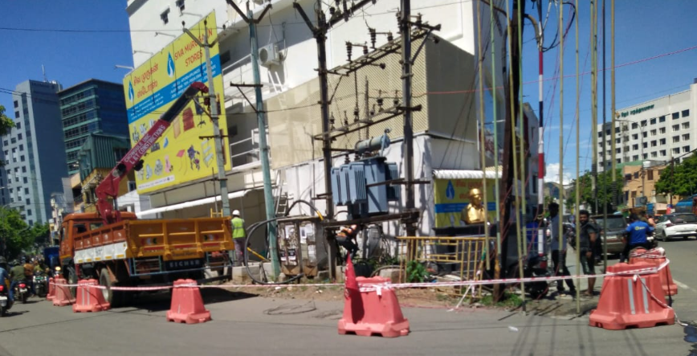

Fig 4.8. Dismantling activity

**4.5.2. Erection of new DTR Structure**

After completion of dismantling activity, the new structure will be erected on the foundation and the fasteners are properly tightened. Once checking the alignment and level of the structure is obtained. Transformer will be erected as in figure 4.9.

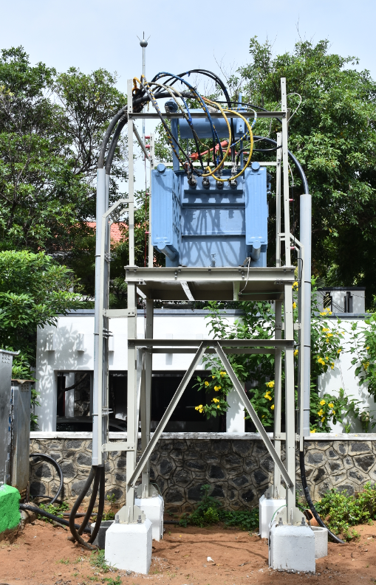

Fig: 4.9.DTR Structure

**4.5.3.** **Cable Termination**

Once the cable ends are removed from the system. The cables are laid through the ducts of the foundation and enters the cable facilitating area of the ring main unit and the termination work is carried out by the competent jointers. The size of the termination kit depends upon the size of the cable.

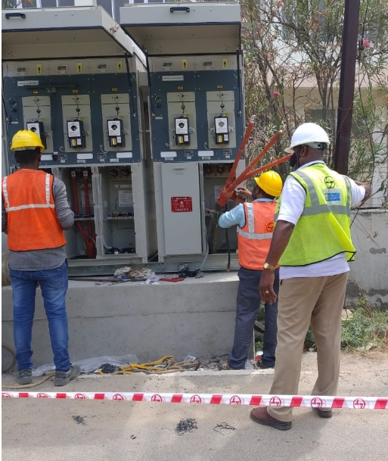

Fig 4.10. Cable Termination activity

Once the termination activity is completed, the lugs are connected to the respective bushing. The cable end termination is properly booted and closed with the gland plates.

**4.5.4.** **Charging of Ring main unit**

Charging of ring main unit is nothing but energizing the unit and connects it to the system when all the sub activities are properly happened and all the connection are done properly without any loose connections.

Before charging, we need to confirm that all the workmen and discharge points are out of the system. The line clearance to be returned and the feeder to be energized.

Once incoming supply reaches the RMU, we can operate the outgoing feeder supply by manually or by remote controlled.

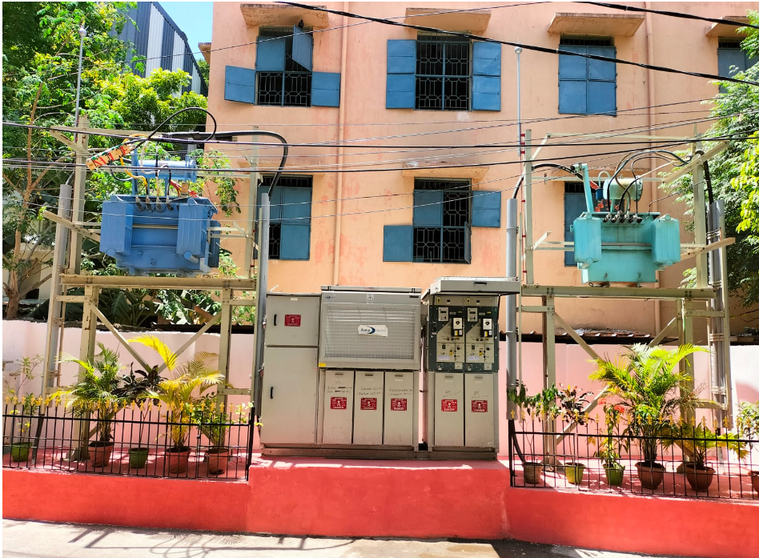

Fig 4.11.RMU unit charged With Distribution Transformers

**CHAPTER -5**

**FRTU (Feeder remote terminal unit)**

**5.1.** **INTRODUCTION**

A feeder remote terminal unit (FRTU) is an electronic device used in power distribution systems to monitor, control and communicate with remote feeders operated by the ring main units. The FRTU acts as an interface between the control system and the feeders, allowing the control system to monitor and control the feeders remotely. The FRTU can monitor, control and communicate with feeders and other electrical devices, such as transformers, circuit breakers, reclosers, and other monitoring and control equipment. It can also be used to monitor power quality, detect power outages, and monitor system performance.

The FRTU is installed in the Ring main unit, having dedicated compartment for housing the SMPS based DCPS and the Batteries, Modems/Routers and other accessories apart from FRTU.

**5.2.** **DESIGN STANDARDS**

The FRTUs are designed in accordance with applicable International Electro-technical Commission (IEC), Institute of Electrical and Electronics Engineer (IEEE), American National Standards Institute (ANSI), and National Equipment Manufacturers association (NEMA) standards.

The FRTU shall be designed around microprocessor technology. For easy maintenance the architecture shall support pluggable modules on backplane. The field wiring shall be terminated such that these are easily detachable from I/O Module. The communication to the SCADA system shall be through Ethernet. The data acquiring from Multifunction modules through MODBUS communication.

**5.3.** **FRTU FUNCTIONS**

A feeder remote terminal unit (FRTU) enables a remote operator to control and monitor the diversified distribution network from a central location. It usually consists of a microprocessor, communications interface, and multiple I/O channels that enable it to act as the interface between a distributed control systems (DCS) and field devices such as sensors and actuators.

In this application, the FRTU is responsible for controlling the switches and breakers that direct the flow of power to customers. It also monitors the current, voltage, and other parameters to ensure that electricity is delivered safely and reliably.

The FRTU shall be capable of performing the following functions:

* Acquires analog values from Multifunction transducers, processing and transmitting to Master stations.
* Receiving and processing digital commands from the master station.
* Data transmission rates - 300 to 19200 bps for Serial ports for IEC60870-5-101 and Ethernet 10/100 Base T interface with IEC 60870-5-104 protocol.
* FRTU have an inbuilt optical coupler to isolate field signals for Digital Input.
* FRTU shall monitor suitable features of external battery availability check through potential free contact as DI signal to FRTU and Suitable provision in FRTU to supervise and prevent accidental serious discharge of battery.
* FRTU have the capability of automatic start-up and initialization following restoration of power after an outage without need of manual intervention. All restarts shall be reported to the connected master stations.
* FRTU shall support web-based monitoring/diagnostics and configuration from remote as well as local.
* It enables Remote database downloading from master station.
* FRTU has Flash storage and internal battery backup.
* Archive FRTU events in logs with 1ms time resolution/10ms discrimination and having capacity over 30,000 events/measurements.
* As the SCADA/DMS system will use public domain such GPRS/CDMA etc., therefore it is mandatory to guard the data/ equipment from intrusion/damage/breach of security & shall have IPSecVPN based security.

**5.4.** **CPU MODULES**

The FRTU will furnish a CPU Module which is responsible for the main processing activities and for communication.

CPU is responsible for handling all protocol emulation, performing data acquisition, and execute control requests. It will take commands from the main station, recognize addresses, create response messages based on the received command messages, and send the messages to the control center.

The main tasks of the CPU Modules are:

* Managing and controlling of the I/O modules
* Reading process events from the I/O modules
* Writing commands to the I/O modules
* Communication to control center and to subordinated devices
* Managing of the time base and synchronizing the I/O modules

The FRTU will also provide Data Archives to save data such as system events from the FRTU, process events, and measuring values with a time-stamp resolution of 1 ms.

The data will be stored in the Flash/EEPROM memory of the FRTU and will not be erased in case of a power failure.

**5.5.** **COMMUNICATION PORTS**

The FRTUs shall have following communication ports to communicate with master station

* The FRTU shall have two TCP/IP Ethernet ports for communication with the Master Station(s) using the IEC 60870-5-104 protocol.
* It shall have a minimum of two RS 485 ports connecting to MFTs in a daisy chain with the MODBUS protocol, with at least 15 analog values including four energy values being considered for each energy meter. It should be able to connect to a maximum of five MFTs per port, with all analog values being updated within two seconds.
* FRTU shall have one Ethernet/USB 2.0port for maintenance

The FRTU shall support the use of a different communication data exchange rate (bits per second) and scanning cycle on each port & different database for each master station.

**5.6.** **MASTER STATION COMMUNICATION PROTOCOL**

The FRTU shall employ IEC 60870-5-104 communication protocol to contact the master station. FRTU communication protocol shall be configured to report analog (except energy values) & status changes by exception to master stations. However, FRTU shall support periodic reporting of analog data and periodicity shall be configurable from 2 sec to 1 hour. Digital status data will be prioritized over analog data. The dead-band for analog value reporting by exception shall be set to 1% of the full-scale value in the beginning. Analog values will be reported to the master station by exception if a specific threshold is exceeded. All analog values and status data shall be assigned to scan groups so that the master station can perform an integrity check on them every 10 minutes (up to 60 minutes per FRTU).

Energy values shall be sent to the master station periodically, with a configurable periodicity of 5 minutes to 24 hours (initially set to 15 minutes).

**5.7.** **ANALOG INPUTS**

The FRTU will acquire real-time values such as active power, reactive power, apparent power, three-phase current and voltage, frequency, power factor, and accumulated import/export energy values from the following sources in the specified manner:

* MFTs installed in RMU
* RTU which will take 4-20 mA as analog inputs to acquire DC battery voltage, etc.

The FRTU's Analog-to-Digital (A/D) converters shall have a digital resolution of at least twelve bits plus sign, with an overall accuracy of at least 0.2% (99.8%) at 25°C of full scale. The FRTU shall be designed for a common mode rejection ratio of voltage inputs of at least 50 dB from 1 KHz to 5 KHz, 70 dB from 5 KHz to 1 MHz, and more than 90 dB at 50/60 Hz. Each input shall be galvanically insulated by a transformer and have suitable protection and filtering to protect against voltage spikes and residual current at 50 Hz, 0.1 ma (peak-to-peak), and overload. The FRTU will be able to handle loads up to 150% of the input value without sustaining any damage to the input.

The total burden imposed by the FRTU analog input circuit shall not exceed 0.5 volt-ampere for current and voltage inputs. As an option, contractor may also provide transducer less solution to connect direct CT/PT secondary.

**5.8.** **STATUS INPUT**

FRTU shall be capable of accepting galvanically isolated dry (potential free) contact status inputs. The FRTU shall provide necessary sensing voltage, current, optical isolation and de-bounce filtering independently for each status input. The sensing voltage shall not exceed 24Vdc (for 24Vdc supply).

Data Acquisition shall be with a resolution of 1 ms Minimum 64 Digital inputs at least in two DI cards shall be provided in FRTU.

The RTU will be set to detect contact actions with a minimum duration of 20 milliseconds. Any contact operations of a shorter duration will not be taken into account and will be considered as if there was no change (due to contact bouncing).

The RTU will accept two kinds of status inputs:

Single point status input (from a normally open or normally-closed contact, represented by 1-bit in the protocol message).

Double point status input will be from two complementary contacts (one NO and one NC) which is represented by 2-bits in the protocol message. A switching device status is valid only when one contact is closed and the other contact is open. Invalid states shall be reported when both contacts are open or both contacts are closed.

All status inputs shall be scanned by the FRTU from the field at 1 millisecond periodicity.

**5.9.** **SEQUENCE OF EVENTS (SOE) FEATURE**

To analyze the sequence of events occurring in the power system, time tagging of data is required which shall be achieved through SOE feature of FRTU with an internal clock with accuracy of 10ppm or better in order to track the sequence of events.

The RTU shall use IEC 60870-5-104 protocol to receive synchronization messages from the master station and assign a 1ms or better time resolution for each event.

In addition, the RTU shall store up to 4000 events in the SOE buffer and transmit the SOE to the Master Station according to the IEC 60870-5-104 protocol. Furthermore, the RTU shall maintain the SOE buffer even in case of power supply interruptions.

**5.10.** **CONTROL OUTPUTS**

The FRTU shall offer the possibility for a main station to choose and change the status of digital output points. These control outputs must be isolated from each other and be used to control power system items such as circuit breakers, isolators, resets, relay enable/disable and other two-state devices, which are supported by the RTU. The switching voltage will be 24 V DC.

A set of control outputs must be provided for each controllable device. When a main station sends a command with the select check-before-execute procedure, the corresponding control output will be switched on for a preset period of time ranging from 0.1 to 2 seconds. Each control output will include one set of potential free NO contact. The output contacts are rated for at least 3 amps continuous at 24 V DC. These output contacts must be able to operate the trip and close coils of switching devices in the RMU. Additionally, the FRTU also consist of heavy-duty relay for security. These relay coils must be connected to diodes to reduce inductive transients associated with energizing and de-energizing of the relay coils, in compliance with the relevant IEC requirements. Local indication is available to determine the health of the card.

**5.11.** **LOCAL/REMOTE SELECTOR SWITCH**

A manual Local/Remote selector switch shall be included with each FRTU that can be used to disconnect power from the FRTU's control outputs and prevent them from being activated. In the "Local" position, the switch will allow the outputs to be tested without applying to field devices. The SCADA system should be able to detect the switch's position through a status input. FRTU with inbuilt local remote selector switch also will be acceptable.

**5.12.** **LOCAL COMMUNICATION NETWORK**

The control unit shall have a MODBUS RS485 port for communication with the station equipment:

* Power Supply monitoring unit
* Protection relay

Modbus RS485 communication is based on a master-slave architecture, with the master initiating and controlling the communication and the slave responding to the requests of the master. The Modbus RS485 protocol supports a wide variety of functions, including reading and writing digital and analog signals, as well as data processing and control operations. The RS485 version of the Modbus protocol uses a differential signal for communication, providing better noise immunity than the original Modbus protocol. The RS485 port is a physical connection that utilizes the RS485 protocol to transmit and receive data between devices in RMU.

**5.13.** **DIAGNOSTIC SOFTWARE**

The FRTU are equipped with a diagnostic system to constantly and automatically check for any hardware or software malfunctions or faults, and report any errors to the connected master station.

Visual indicators such as LEDs shall be present to give an indication of the FRTU's current state. Configuration data shall be stored on SD Cards so that modules can be exchanged without having to reconfigure them. An extensive monitoring system shall be in place to ensure adequate functioning of the FRTU. System and error states shall be communicated to the Control Centre by way of System Events.

Lastly, remote diagnostics shall be enabled, allowing for remote analysis, configuration and signal value checking of the FRTU via a Web-Server connection over a LAN or WAN.

Remote access via Internet shall be combined with authority privileges for the user for following activities:

* Monitoring the FRTU-produced internal error messages
* Monitoring and checking the FRTU configuration and the status of all connected process signals
* Checking the current version of the configuration file
* Downloading or uploading the FRTU configuration file
* Checking and downloading revised software files for the FRTU CPU modules
* Uploading the archive files

**5.14.** **TROUBLESHOOTING**

FRTU shall have proper diagnostic tool for trouble shooting the failures related to the following from remotely as well as locally.

* Communication of FRTU with master
* Communication of MFT with FRTU.
* Communication of DI/DO

**5.15****.** **INPUT DC POWER SUPPLY**

The FRTU will be powered from a 24 V DC power supply system. The RTU shall not place additional ground on the input power source. The characteristics of the input DC power supply shall be

(a) Nominal voltage of 24 VDC with variation between 20.4 and 28.8 Vdc

(b) 10% ripple of nominal voltage for 10 min

(c) Battery and battery charger should capable for all FRTU required operation and Aux. supply to Modem & MFT and DC transducers etc.

**5.16.** **CYBER SECURITY**

Cyber security for Feeder Remote Terminal Units (RTUs) is an important concern for any power utility. Feeder RTUs are connected to the utility network and are responsible for controlling the flow of electricity in the system. To ensure their security, security measures must be implemented at the FRTU, the communication network, and the utility operations center.

At the RTU, physical security measures should be implemented to prevent unauthorized access to the device. Additionally, authentication and encryption should be used to ensure that only authorized users can access the RTU.

The communication network should also be secured. This includes encrypting communication traffic, employing access control measures, and monitoring traffic for suspicious activity.

Finally, the utility operations center should have Door lock alarm integration with FRTU and Security Event Logging and viewing of the same through the web browser. It shall also be possible to upload this log into CSV files.

**5.17.** **ARCHIVES**

FRTU Events shall be archived in logs in CPU internal memory or external SD card. FRTU Events shall be stored in the archive logs with a time resolution of 1ms and a discrimination of 10ms, with a capacity of at least 30,000 events and measurements. These logs can be accessed through a maintenance tool connected to the FRTU or sent to the SCADA on request, with the content and file name being configurable. The logs will be formatted as a .csv file.

**5.18.** **FRTU DATA BASE CONFIGURATION & MAINTENANCE SOFTWARE TOOL**

FRTU database configuration & Maintenance software tool shall be required to perform the database modification, configuration, compilation and documentation. The database compiler shall provide error detection services. It shall also perform the downloading of the compiled database into the FRTU database.

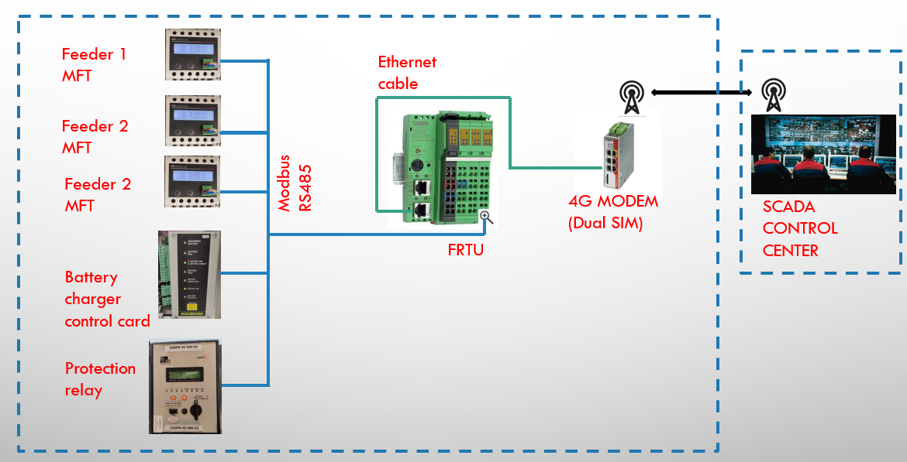

Fig 5.1. Architecture of FRTU employed RMU control

**CHAPTER -5**

**CONCLUSION AND FUTURE SCOPE**

The Ring Main Unit employed in power distribution network ensures to prevent the voltage supply from dropping off at various load substation. In a typical urban ring main arrangement, the loss of supply is immediately replenished through manual switching, and it increases the reliability of medium voltage supply in case one of its section fails to function. Despite being at the same meeting point, both ends of the ring are capable of supplying power in every distribution transformer located within the ring.

The ring main unit forms a ring main power distribution system, providing a two-way power supply. The main bus bar of the ring main unit receives power from the trunk line and then distributes it to each branch. Even when one of the trunks fails, the branch is still able to receive power from the other trunk, ensuring a stable and reliable power supply.

The ring main unit is small in size and can adapt to all kinds of buildings. It can be used for long-term stable power supply and infrequent high voltage switching operation. Ring main unit, because of its inherited properties is now widely used in residential buildings, public places, factory buildings and other buildings, especially in medium and small capacity compact stations.

The future of Ring Main Units (RMUs) in power distribution automation is very promising. Because they are becoming increasingly popular for their ability to provide increased safety, efficiency, and cost savings. As the technology continues to improve, RMUs are becoming the go-to solution for many power distribution applications, including those in remote areas. Additionally, advancements in communication technology are making it possible for remote monitoring and control of RMUs, allowing for more efficient and cost-effective distribution automation.

**REFERENCES**

1. C sec vendor documents
2. <https://ashidaelectronics.com/portofolio/frtu>
3. <https://en.wikipedia.org/wiki/Ring_main_unit>
4. <https://www.allumiax.com/blog/ring-main-unit-in-electrical-distribution>
5. Lucy vendor documents
6. Project Quality Plan, Larsen & Toubro Ltd.
7. Safe Operating Procedure, Larsen & Toubro Ltd.
8. Standard Operating Procedure, Larsen & Toubro Ltd.
9. V.K. Mehtha, Principles of Power Systems